ALA1.2 The two genetic dimensions of types of varieties
Prerequisites
eModules_1-5 in Principles of Plant Breeding and Crop Improvement
Purpose
Reinforce understanding the level of homozygosity and homogeneity of different types of varieties.
Background
The level of homozygosity and homogeneity of different types of varieties determine important properties, such as uniformity, exploitation of heterosis or hybrid performance to maximize yields, and yield stability. In addition, understanding the genetic composition of breeding materials with regard to these two “genetic dimensions” may affect, which molecular methods can or cannot be used.
Tasks
- Draw a 2-dimensional graph system. The y-axis represents the level of genetic heterogeneity from 0-100%, the x-axis represents the level of genetic heterozygosity from 0-100%.
- Place in this graph the following types of varieties: 2-way, 3-way, 4-way hybrids; line varieties; population varieties; synthetic varieties; clone varieties; landraces of self-pollinating crops.
- Discuss the advantages and disadvantages of establishing hybrid varieties for self-pollinating crops such as wheat and tomato.
- Discuss the advantages and disadvantages of establishing hybrid varieties for crops, that have so far been vegetatively propagated.

Tentative answers (can differ, based on context / assumptions made)
1, 2)
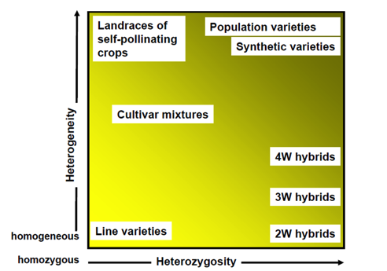

3) - Advantage: increased performance due to exploitation of hybrid performance and/or heterosis.
- Disadvantages: Production of crosses in autogamous species can be demanding and thus, costly. Hybrid effect in autogamous species is usually not as pronounced as in allogamous species. It is thus a balance, whether increased seed price is accepted for incremental yield increases over traditional line varieties.
Also: farmers can reproduce line but not hybrid varieties – can be advantage or disadvantage, depending on the perspective.
4 ) Both hybrid and clone varieties are uniform and highly heterozygous. The main difference is the mode of propagation: sexual versus asexual. Generally, asexual reproduction is more laborious, and more importantly, it is more challenging to limit pathogen transmission (seed is “cleaner” with regard to pathogens). It is more costly, to produce vegetative propagules in areas with low pathogen pressure, have increased measures to evaluate for presence of pathogens, etc. Moreover, storage of vegetative propagules (such as potato tubers) can be more demanding due to size, and is usually not possible over a long term. However, automated vitro multiplication procedures might enable pathogen free and low cost large scale asexual propagule multiplication in future.

