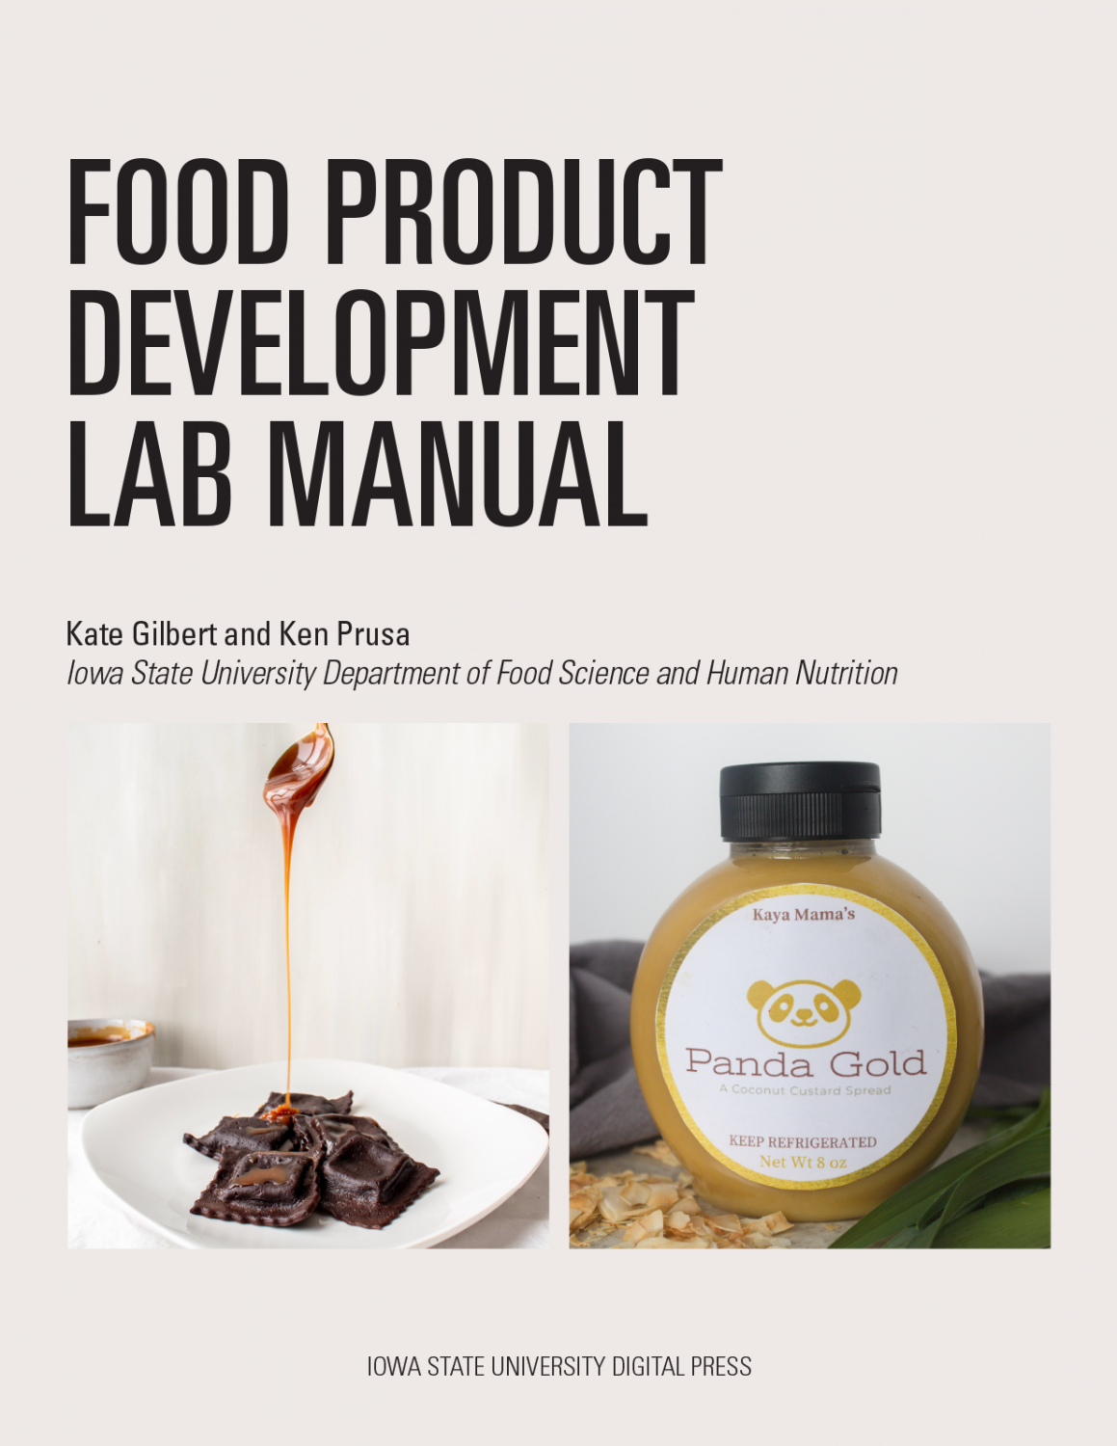

Food Product Development Lab Manual

Food Product Development Lab Manual

Kate Gilbert and Ken Prusa
Iowa State University Digital Press
Ames, Iowa

Food Product Development Lab Manual by Kate Gilbert and Ken Prusa is licensed under a Creative Commons Attribution-NonCommercial-ShareAlike 4.0 International License, except where otherwise noted.
Suggested citation: Gilbert, K. & Prusa, K. (2021). Food product development. Ames, IA: Iowa State University Digital Press. DOI: https://doi.org/10.31274/isudp.2021.66
Published by the Iowa State University Digital Press, a division of the University Library at Iowa State University.
701 Morrill Rd, Ames, IA 50011, USA
E-mail: digipress@iastate.edu

Contents
- About This Lab Manual
- Introduction
- Introduction to Food Product Development
- Course Timeline
- Required Skills
- Creativity
- Resourcefulness
- Communication
- Teamwork
- Attention to Details and Notetaking with Lab Notebook Expectations
- Lab Policies (Lab Modified Good Manufacturing Practices)
- Formulation
- Ideation - Coming Up with a New Product Concept
- Ideation Worksheet - Complete Before the 1st Day of Class
- New Product Concept Market Plus Grocery Store Research.
- New Product Concept Market and Grocery Store Research Worksheet
- Consumer Concept Testing of the Gold Standard
- Formulation Design - How to Set Up Experiments and Track Variables
- Formulation Calculations - Tracking Moisture and Fat Content
- Formulation Steps – Order of Addition of Ingredients and Function of Each Step.
- Using Genesis Software to Generate Nutrition Facts Panels
- JAR Attribute Testing
- Industrial Ingredients – Purpose, Sourcing and Conversion
- Industrial Ingredient Worksheet
- Processing
- Components of Processing and Where to Start
- Analytical Testing
- Scale-Up Expectations and Value
- Processing Equipment Considerations
- Good Manufacturing Practices
- Writing Standard Operating Procedures for Your Product
- Constructing Batch Sheets For Scale-Up
- Setting Ingredient Specifications
- Food Safety Plans
- Commercialization
- Commercialization Introduction
- Home Use Tests (HUT)
- Shelf Life and Abuse Testing
- Finished Product Specifications
- Choosing Packaging for Your Product
- Designing a Package Label
- Calculating Suggested Retail Price (SRP)
- Student Conclusions
- Instructor Notes

1

About This Lab Manual
Before using this lab manual, it is helpful to know a bit about the origins and goals of the content. Ken Prusa has been teaching food product development at Iowa State University for over 20 years, building the foundation and layout of the course over time. The course meets 7 hours each week, split between two afternoon sessions. A short amount of time is used for announcements and reminders. The remainder of the time is used for teams to work in the lab and develop their product. Teams of three or four students develop a new food product working through formulation, processing, and commercialization sections throughout the course. Teams present to an industry board at the end of the formulation and commercialization sections. Kate Gilbert joined Ken five years ago and has slowly added content for the course.
One of the goals of adding instructions, explanations, and examples for the course has been to let student teams be as resourceful and independent as possible. With limited instructors for a large lab-based course, it is important to eliminate answering the easy and repetitive questions and focus on guiding students while they problem-solve through the more complicated, project-specific challenges. The second goal is related to the first and is to push the boundaries of what students can accomplish in a one-semester 3-credit course. Each team develops a product from start to finish, but there is potential to increase the number and depth of components that can be researched. The more efficient student teams can be (with added instructions and resources), the more can be accomplished and a more real-world experience will be achieved.
In addition to this lab manual, this product development course includes video lectures, scenarios, and questions to check student understanding. It is set up in a pseudo flipped classroom approach. Students view content and answer questions before working through the corresponding tasks in class. The lab manual reinforces the content students learned outside of class and acts as a guide for the students while working in class.

Why an Open Educational Resource (OER)
There are a few reasons that we chose an OER instead of a published book. One reason is that we have received resources, methods, and suggestions from industry members that we have incorporated into the course and course content over time. While we have added our knowledge and developed the content, we do not feel like it belongs to just us. We recognize and appreciate that building this course has been a supported effort and we want to thank all of the industry members who have shared their time, knowledge, and resources with us. Another reason that we chose OER is the format of the material. We refer to this book as a lab manual because we want it to be actively used throughout the development process. The content includes some background context but is written with direct and practical instructions as the main focus. The last reason is that we know each product development course is set up a bit differently. It is most useful to have materials that can be adapted to fit the needs of each individual course and an OER makes that possible.

About the Authors/Course Instructors
Ken Prusa received his Ph.D. in Food and Nutrition from Kansas State University, spent two years at the University of Missouri in Columbia, and then joined the faculty at Iowa State University in 1985. Ken is a Professor of Food Science and Human Nutrition and is Professor-in-Charge of the Sensory Evaluation Center. He works closely with the food industry in new product development and product quality optimization through sensory testing. Ken helped develop the course FSHN 412, Food Product Development, at Iowa State into what we believe is the best experience possible for our students entering food-related careers.
Kate Gilbert is an alumnus of the food product development course, graduating with a Bachelor of Science in Food Science in 2007. She worked in technical services and research for the Grain Processing Corporation and completed a Masters in Food Science from Kansas State University before returning to teach at Iowa State University in the fall of 2014. Kate transitioned from industry to academia because she wanted to share real-world experiences with students to better prepare them for their careers. Her approach to teaching is to meet students where they are, connect new information to what they already know, and then allow them to understand and apply that information. In addition to teaching a variety of courses, she coordinates internship opportunities, advises the Food Science Club, and is active in the Iowa Section of the Institute of Food Technologists.

Thank You to Contributors
In addition to contributions from food industry members, we would also like to thank Abbey Elder for all her help with the OER Grant process and answering all our questions along the way, Derek Schweiger for reviewing first drafts of content and finding great references, and Sarah Gilbert for diligently editing the whole manual.

I

Introduction
Jump into product development by learning the basic process, roles involved, and typical timelines.

1

Introduction to Food Product Development

To start, let’s think about what product development is:
- How new things show up in the grocery store or in foodservice
- The process of creating, processing, and commercializing a new food product
- The process generally takes a group of people from different disciplines working together to develop (or improve) a product.

Product Development Key Stages
- Ideation
- Formulation
- Processing
- Commercialization
At each stage, or even within the stages, there are checkpoints to decide to continue or stop the project. This can be done through a Stage and Gate System like the example shown here or it can be done in a modified system. The principle is the same, though, to develop new products strategically and use time and resources wisely.

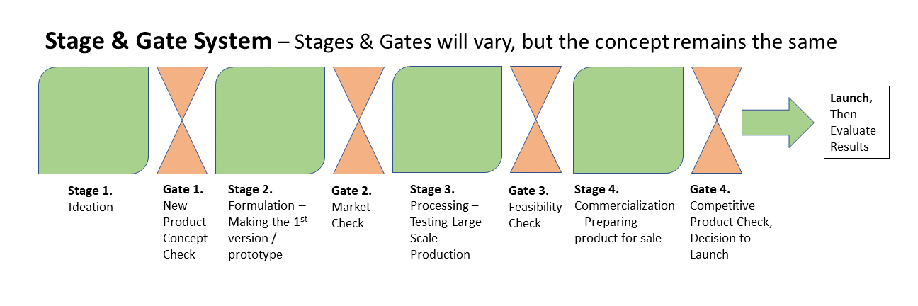

Typically this Stage and Gate process works like a funnel. You may start with 12 to 15 ideas and then research and evaluate those ideas. Some ideas will get discarded because you will find the product concept already exists. Others will get discarded because the ingredients or processing will cost more than what consumers are willing to pay (based on products in the relevant category). Some ideas will seem great, but will be too niche and will not have a large enough target audience to be successful. Once the ideas have been narrowed down, the best 3 to 5 ideas may be moved to the Formulation stage. In this stage, the product will be made on a small scale and consumer testing will be done to confirm interest. Then products will go through the second gate to determine which products have enough consumer interest to continue. During the Processing stage, 2 to 3 products are scaled up on larger equipment. This helps determine production costs and efficiency. Food safety and quality testing also are done to determine how to produce a safe and consistent product. Shelf-life testing is conducted at the end of the Processing stage to make sure the product will remain at an acceptable and safe quality long enough for the product to made, shipped, purchased, and consumed. The third gate evaluates production, food safety, quality, and shelf life to decide which products can actually be made efficiently and consistently. The Commercialization stage includes work to get the product ready to sell on the grocery store shelves. Typically this includes the final costing, additional consumer sensory testing, and package design. The final gate makes sure that no errors or significant drawbacks have been missed before the product is launched. Through the Stage and Gate process, 12 to 15 ideas may get narrowed down to 1 or 2 products. The Stage and Gate process allows many ideas to be considered efficiently. The more viable the idea, the more time and work is needed. When an obstacle is found at a gate, no more time or resources are committed to that idea.
Each company may work through the stages of product development a bit differently depending on resources, timelines, and product types being developed. In a product development course, a product is likely developed from start to finish, so more market, consumer, and product research will need to be done during the ideation stage to catch significant drawbacks.

Ideation
Often the most difficult part of product development is coming up with the initial idea. Many food products exist in the marketplace, so coming up with a new food product that does not exist and consumers are interested in buying can be a challenge. It is best to simply jump in and start generating ideas. From there, concepts can be refined and narrowed down. Ideas can come from a variety of sources. Some ideas are for a brand-new product and some are for a line extension of an existing product. Once ideas have been generated, it is important to identify the target customer. Trends are followed closely to determine what is new and upcoming. Trends often spark ideas for new products. Trends change over time, so it is difficult to list current examples, but convenience products, comfort foods, and plant-based foods have been trending over the last few years.
Some issues with ideation include regional vs. global preferences and market size vs. target market. Flavors that are commonly known and liked in the Midwest may not sell well in other parts of the country. Consumers outside of the Midwest may not like those flavors or may simply be unfamiliar with the flavors. If your target market is a small part of a product category and the product category itself is small, there may not be a large enough market share for your product. It also can be a challenge to realize that just because you like something, many others may not. We tend to develop products we like, but sometimes you may have to develop a product for a target audience that does not include you.

Formulation
- Making the new product!
  - Procure ingredients and make them into a product on a small laboratory scale
  - Produce a “gold standard” of the new product

- Possible issues
  - Sourcing ingredients and ingredient costs
  - Product shelf life (often not tested in formulation, but needs to be considered early in the process)
  - Can the product really be made on a large scale?
  - Avoid Patent and Copyright infringement

Processing
- The formulated product process is “scaled up” to produce greater volumes
- Often the process is “scaled up” more than once.
  - Pilot plant testing
  - Plant testing

- There are always product changes with scale-up.
- Quality & Proximate Analysis testing done to set specifications, determine food safety concerns, and estimate shelf life
- Processing experiments and runs allow a more accurate product cost to be determined (include processing efficiency, rework used, etc.).
Processing Key Questions:
- What effect will the process have on the product attributes
  - Sensory Attributes
  - Nutritional Profile
  - Product Specifications
  - Shelf Life
  - Overall Functionality

Commercialization
- Once the new product has been made successfully, it is sent to commercialization to launch the new product into the store for sale.
- Steps include:
  - determining packaging
  - creating a label (logo, nutrition facts, etc.)
  - finalizing costs
  - developing advertising and/or literature for the product

Commercialization Key Questions:
- How should the product be positioned for the best sales?
- What attributes do you highlight?
- Where does it go in the grocery store (should consider this throughout the development process)?
- What effect will the distribution system have on product quality?
After the launch of a new product:
- Determine if the new product was successful.
- Success can be measured by:
  - Growing interest, increase in sales
  - Market share
  - Company sales revenue

Key Team Members
It takes many roles to develop a new food product. A product development team can be very successful with all members contributing an expertise. The challenge is communicating effectively to make sure everyone is on the same page with the status and goals of the project. Key team members include product development, engineering, production, purchasing, quality, regulatory, marketing, sales, and upper management. Their typical roles are laid out below.

Product Developers
- In charge of developing new products, especially in terms of the hands-on testing and managing the development process
- May be the Team Leader
- Duties:
  - Formulate Product
  - Determine Sensory Attributes
  - Run Shelf Life Testing
  - Know Food Safety Concerns
  - Test the Process
  - Consider Nutrition
  - Calculate Costs (may need input from others)

Engineering and Production
- Engineers & Production Managers help determine Process Design:
  - Equipment Design and Maintenance
  - Process Controls
  - Production Costs (line speeds, overhead cost)
  - Employee Training
  - Sanitation

- They may also help with Package Design
  - Shelf Life
  - Handling
  - Cost
  - Consumer Safety
  - Consumer Handling

Quality
- Ensures consumer expectations are met
- Sensory and Quality attributes are tested to make sure the product meets specifications
- Food Safety
  - HACCP and Preventative Controls plus Prerequisite Programs
  - Microbiology Testing
  - Foreign Material Testing
  - Process Checks
  - Incoming ingredient and packaging safety checks

Regulatory
- Makes sure the new product is legal and safe
- Coordinates a Generally Recognized As Safe (GRAS) dossier if necessary (typically for ingredient development)
- Regulations
  - Product Name
  - Standard of Identity
  - Nutrition Labeling
  - Product Codes

Marketing & Sales
- Defines product market and positioning
- Confirms consumer need for a new product through surveys and consumer data
- Develops advertising strategy
- Monitors competitor’s sales and new product introductions
- Helps design product packaging, especially tied to attracting the target audience
- Has input on the product name

Challenges of Product Development
- Just because you think it is a good idea, does not mean everyone else does.
- Sometimes things just do not work like they are supposed to (scale-up changes product characteristics, shelf life is not long enough, low consumer acceptance, etc.)
- Ingredient sourcing and costs
- Processing and equipment limitations
- Communicating with a Multidimensional Team can be difficult because each background has their own:
  - Area of Expertise
  - Goals and Objectives
  - Ability to understand other disciplines
  - Can be overlap or gaps in functions depending on company structure

Timeline for new product development
- Quick: 3-6 months
  - A line extension for an already existing product
  - Example: A new flavor of a popular soda

- Average: 6 months-1 year
  - A new product, but still can be made on existing equipment
  - Example: A new type of cereal

- Long: 1-3 years
  - A brand new product – could be hard to make or new equipment may need to be designed/purchased.
  - Examples: co-extruded snacks and plant-based meat alternatives
  - Developing a new ingredient often takes longer than developing a finished food product because there are more regulatory and sales hurdles involved.

Recap on the Product Development Process
- Product Development is the process of creating, processing, and commercializing a new product.
- New products need to be of interest to a target market.
- The timeline can range from 3 months to 3 years.
- Product development teams are made up of members with a variety of backgrounds.

Product Development Scope
It is important to be able to ideate openly & creatively. However, ask yourself, “Does the product already exist?” and “What are our company’s new idea limitations?”. Below are common limitations for product development courses:
- Avoid mixes, line extensions, and assembly products.
- Avoid expensive ingredients or be ready to discuss how to pay for them.
- Typically a course does not have an alcohol license.
- CBD oil is not yet legal in food items in some states.
- Processing equipment availability needs to be considered for your new product idea.

2

Course Timeline
It is difficult to fit the whole product development process into a semester course, but the goal is to make the experience as real-world as possible while fitting in as much of the development process as possible. All components will be explained further in additional chapters. In general, though, each section of the course is described below. The semester is split fairly evenly between the three sections. It is important to hit the ground running in this course!

Formulation – 5 Weeks
During this period your team will be responsible for ideating and selecting a formula for a new food product, determining consumer expectations, producing a gold standard, and evaluating your product through consumer and instrumental testing. At the end of this section, your team will have a gold standard product that will be able to be converted into a processable formula. A Formulation Board of Directors meeting will be scheduled for the end of the Formulation section.

Processing – 5 Weeks
During this period your team will be responsible for perfecting your processable formula made with industrial ingredients. You will scale up your formula in the laboratory and under plant conditions as applicable. Your team will be involved with processing and process development, food safety analysis, and measuring quality attributes.

Commercialization – 5 Weeks
During this final period, your team will address issues including consumer acceptance and instrumental testing of your product from your scaled-up process, shelf-life testing, nutritional labeling, and final package and label design. You will present your product and final shelf-ready package to the Board of Directors at the end of this section and will also share your new product with the department.

II

Required Skills
In order to be successful in product development, this course, plus your careers moving forward, there are a number of skills that are important to use and work to improve. This Required Skills section will cover creativity, resourcefulness, communication, teamwork, attention to detail, and best practices for product development.

3

Creativity
Some of us are naturally creative. For others of us, it takes some work. Either way is okay as long as you are willing to work on your creative skills.
To start, let’s consider the definition of create:
- to make or produce something
- to cause something new to exist
- to produce something new by using your talents and imagination
Think about creativity in terms of looking at a problem or situation and thinking of all of the ways to solve the problem or move a situation forward. It may include thinking “outside the box” or asking questions that start in “what if” or “why not”. Use your imagination, too. Creativity is often a mix of dreaming and using logical thought to make the dream a reality.
If creativity does not come naturally to you, that is okay. Here are a couple of techniques that can help.

Mindmapping:
“Developed by Tony Buzan in 1972, mindmapping is a visual ideation technique that encourages you to draw connections between different sets of ideas or information. You’ll start by writing a keyword in the middle of the page (this could be a product category or the start of an idea). On the same piece of paper, you then surround this word with any and all ideas that come to mind (different flavors, forms, trends). Finally, you’ll think about how these ideas are connected, depicting said connections with lines and curves—resulting in a visual map.” (Stevens, 2020)

SCAMPER:
SCAMPER is a checklist that helps you to think of changes you can make to an existing product or solution to create a new one. This can be done in a list or table form. Developed by Bob Eberle (1996), the changes SCAMPER stands for are:
S – Substitute – components, ingredients, packaging size/materials, people (people could be the target audience).
C – Combine – mix, combine with other assemblies or food types, integrate.
A – Adapt – alter, change function or use, use part of another element.
M – Modify – increase or reduce in scale, change shape, modify attributes (e.g. color, flavor).
P – Put to another use (e.g. breakfast foods as snacks).
E – Eliminate – remove elements, simplify, reduce to the simplest component.
R – Reverse/Rearrange – turn inside out or upside down, or reverse the use of the food (soup in a sandwich, cheese inside a pretzel, etc.).
Start with a product category or specific product and then work through the SCAMPER list to see what possible products emerge. This method may be more effective for line extensions (think Starburst jelly beans or Reese’s peanut butter cups in holiday shapes), but it can also help with brand new product ideas. Almost all new food products come from a food/flavor/format that consumers already know and buy (otherwise it is hard to explain what the new product is). Examples of using SCAMPER are available online.

Stevens, E. (2020).
. CareerFoundry. Retrieved June 6, 2021 from

4

Resourcefulness
We do not spend enough time discussing resourcefulness, but we would argue that resourcefulness is one of the most important skills you can possess and use in this course and moving forward in your career. It is okay if you do not remember everything you ever learned; it is more important you can find and understand the information you need to successfully move a project forward.
Merriam-Webster defines resourcefulness as “able to meet situations, capable of devising ways and means.”
We would take that definition a step further and define resourcefulness as the ability to use instructions, examples, and given resources, plus search additional references as needed, to determine how to proceed with a project and solve problems that arise. This lab manual and additional references will allow you and your team to work through the product development process predominately independently. Faculty will be available to answer questions specific to your team’s product and project, but will not answer questions that can easily be found in provided references. The goal is to optimize time management, increase efficiency, and give you the power and ability to develop a new food product as a team. There are many different ways to be resourceful, but using this skill typically begins by asking yourself “How could I figure this out?” or “Where could I find a reference with that information?”



5

Communication

Course Policies and Best Practices

For Written Communication:
1. It is the student’s responsibility to submit assignments on time—points will be deducted from late assignments unless the student has communicated with faculty before the deadline.
2. Weekly reports and strategic objective reports should be written in complete sentences that are grammatically correct and free of spelling and typographical errors. You are expected to write clear and concise statements that express logical thinking and demonstrate professional quality and effort. If there are errors in your writing, it is easy to assume there are errors in your food science work, even if that is not the case.
3. Formatting of reports needs to be considered. Use headers and titles to make the components of the report easy to find and read. You are highly encouraged to follow the layout and order of report components given in the instructions.
4. Team reports should be edited for consistency among writers, at least enough that it is not obvious when a new writer starts. Make sure to use consistent terminology and have a team consensus on the results of the project.
5. Figure out what works best for you to produce professional written communication.
Some recommended practices include:
- Outline the main points before starting to write. Make sure you know what you want to say and figure out a logical order to make your points.
- Start by proofreading once.
  - Pay attention to underlined words when using Microsoft products.
  - Use Grammarly. The general version is free and the upgraded version is often provided for university students. Grammarly will keep you from making mistakes like the one shown below.

- Read your writing out loud. This will help you catch awkward sentences or phrases.
- Proofread at least one more time after reading your work out loud.
- Have someone else you trust read your work and make comments.



For Presentations and Verbal Communication:

1. Follow the written communication guidelines above, especially in terms of clear formatting, organization, and removing grammatical and spelling errors.

2. For Presentation Slides:
- Organize your material and determine the best way to format and lay out the content.
- In general, keep the information you want to share as simple and straightforward as you can.
- Limit bullet points and text on slides, then make the text larger to fill the space.
- Avoid too many transitions and busy backgrounds.
- Use high-quality images.
- Make graphs and tables easy to read.
  - Be careful not to crowd a slide with too many graphs or tables.
  - Make your font on graphs and in tables large and easy to read. Faculty typically enlarge the font upon review.
  - Right-align numbers in tables.
  - Use a consistent number of digits after the decimal place per column.
  - Make sure the sum of the numbers is double-checked and correctly displayed.

- For formulation tables, use “Batch Weight (in grams)” and “Percent by Weight” as column headers.
- Ingredient Statements need to include the ingredients within ingredients.
- Be careful about making health or nutrient content claims (make sure you have read all of the regulations).
- Proofread. Everyone in your team should proofread the presentation slides.
- Convert to PowerPoint if you start in Slides (be careful of formatting changes).
- Email your presentation to faculty for review, typically 1-3 days before the Board of Directors meeting.

3. For the Verbal Presentation:
- As a team, decide who will cover which part(s) of the presentation.
- Work on your part, deciding what to say and how to say it.
- Remember transitions, or how to get from one topic to the next.
- Practice the presentation alone and as a team. Does it flow? Is your timing in line with recommendations?
- Polish is often in the details. Determine who will pass out the food samples, who will introduce the team, and who is most comfortable answering what type of questions at the end.
- The use of notecards is not allowed for the Board of Directors’ presentations.
- Business casual dress is also required for presentations (specifically no jeans allowed).

4. For Verbal Communication in General:
- Most verbal communication is not actually the words we say, but how we say those words.
- It is far better to over-communicate than to under-communicate, so when in doubt, speak up, send an extra text or email, and make sure your team members are on the same page.
- We all communicate differently. Ask for clarification if you are unsure what someone else means.

6

Teamwork
You are asked to work in teams often, so you are used to the idea. However, it is worth taking a step back and thinking about how best to work in a team.

To start, answer the following questions:
What is the best team you have been a part of and why?
- Was there a synergy?
- Comradery?
- A clear plan?
- Was everyone engaged?
Think about how you can be a good team member. This can be in general and also based on your strengths. Communicating, active listening, resolving conflict, setting and meeting expectations, motivating others, staying organized and on task, and working with your team to reach a consensus are all beneficial attributes to bring to a team. Discuss best practices and expectations together as a team before you start your project. Being a good team member is not just about your intentions; it is also how you are perceived. Peer evaluations will be used to provide feedback and improve teamwork.
Babe Ruth said it well, “The way a team plays as a whole determines its success. You may have the greatest bunch of individual stars in the world, but if they don’t play together, the club won’t be worth a dime.”

Building an Effective Team
Check out the team-building pyramid below adapted from Grow (2011). In order to build an effective and strong team, it is important to start from the bottom with vision, expectations, and then connectivity. Once a foundation has been laid, trust can be built and problem-solving can start. Too often teams start at the top. It is difficult to effectively communicate and make decisions if team members are not on the same page in terms of vision and expectations and have not built trust with each other.

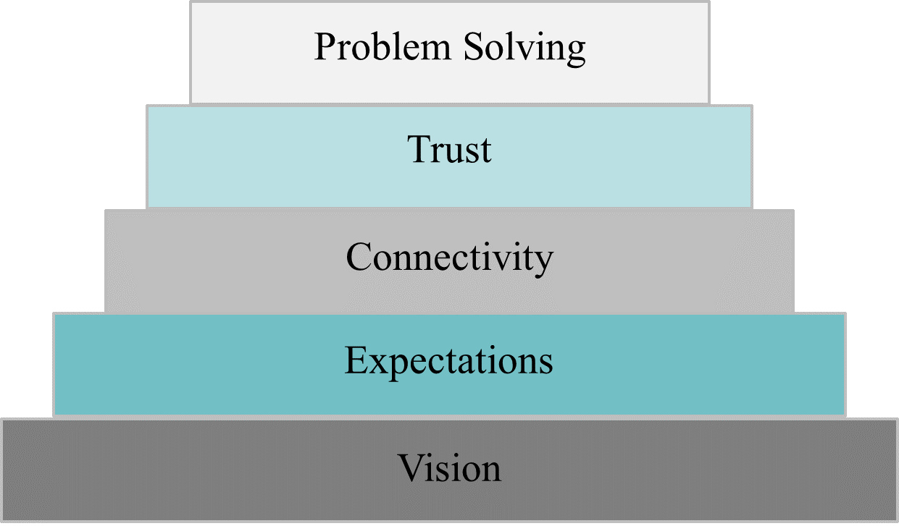

Balancing the Team and Tasks
Forming and maintaining an effective and successful team takes work. One of the challenges is how to allocate time and resources to balance getting things done and keeping the team cohesive and working well together. Below is an illustration of this challenge from Grow (2011) . It is a good idea to keep this balance in mind throughout the project. At times the scale may tip one way or the other, but it is important to keep both the project and team in mind as decisions are made.

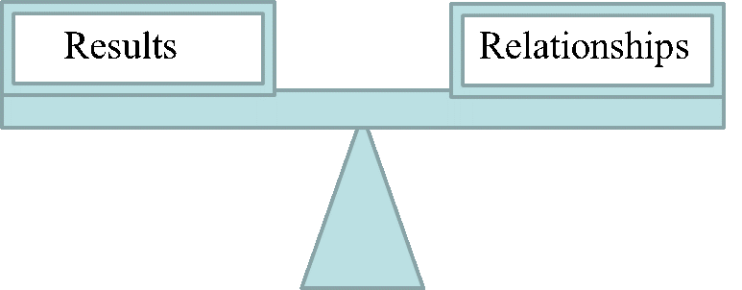

7

Attention to Details and Notetaking with Lab Notebook Expectations

Attention to Detail

Whether a project succeeds or fails is often in the details. Make sure to slow down and pay attention to the little things, plus record detailed observations in the lab notebook. Small changes in ingredients or processing steps can change the final product. If you think there may be a small problem with your project, make sure to discuss it. Small problems have a tendency to turn into larger problems down the line.

Product Development Lab Notebook Expectations
It is important to keep an accurate and legal lab notebook during the product development process. The format to follow is listed below.
- Enter the project name in the front of the notebook.
- List the names of your team members and record your full signatures and initials.
- Allow room for a Table of Contents (usually 2-3 pages). Table of Contents should include each lab date, description of the entry, and corresponding page numbers. The entry needs to be detailed enough to know what was done in the lab that day. For instance, “Formulation Day 5” is not descriptive enough, but “Ran Drum Dryer to Produce Dried Sweet Potato” is descriptive enough.
- Enter each day in chronological order – do not leave spaces or blanks to be filled in later.
- As your project progresses, record a complete, factual account.
- Organization each day should include the date including the year, objectives, materials and methods, results and conclusions, and plans for the next class period.
- The project notebook is provided for the course.
- One notebook per team – your team is responsible for the notebook.
- Treat the notebook as a legal document.
- Information in the notebook should be considered confidential at the corporate level.
- Only team members should write in the notebooks.
- Notebooks should be bound or electronic.
- Use black or blue permanent ink only.
- Enter data immediately and not on scraps of paper or paper towels to be copied later.
- Keep your writing legible, accurate, neat, and clean.
- Never erase, scratch out, or scribble over an error.
- ONLY single lined-out errors with initials and corrections next to the lined-out errors are acceptable.
- Record your formula and procedures in detail.
- Include everything in sufficient detail for another person to duplicate your work.
- At the end of each research period, line out blank spaces, have all team members sign, and have your supervisor sign and date.
- Any innovative idea should be documented by the inventor.
- Complete notebooks should never be underestimated – and should be treated as an integral part of the job.

8

Lab Policies (Lab Modified Good Manufacturing Practices)

Good Manufacturing Practices (GMPs)
Lab procedures have been modeled after typical plant GMPs. We will work under GMPs at all times. Do not be surprised by unannounced inspections. You will lose points for GMP violations. Products made not following GMPs will be tagged and possibly discarded.

Good Manufacturing Practices will include, but not limited to, the following:
- Use good judgment when ill or not feeling well…contact the faculty if you are unwell.
- Clean lab coats or chef coats are required.
- You must wear fully enclosed shoes while in the laboratory.
- Hairnets are required and will be provided. Please reuse.
- No chewing gum or chewing tobacco allowed in the lab.
- No outside food or drink may enter the lab stations.
- No loose-fitting jewelry or watches.
- No fingernail polish or fake nails are allowed unless covered with gloves.
- Wash hands with soap and hot water before starting work and as necessary during work.
- Clean and sanitize work surfaces before and after use.
- Use an acceptable cutting board when using knives.
- Be aware of proper food handling temperatures (cooling and heating). Thermometers will be provided.
- Do not allow food to sit at room temperature for more than 2 hours.
- Use a serving spoon for serving and a sampling spoon for tasting.
- If food contacts the floor, it is no longer food grade and must be disposed.
- Food must be covered if removed from the food lab.
- Clean your work area after you are finished for the day.
- Wash and dry all equipment, dishes, and utensils before returning each to the correct storage space.
- Place all trash in proper receptacles.
- Make sure your sink, range top, and work area are clean before you leave.
- Hang wet towels on the drying rack before you leave.
- If you use a laptop with a power cord, make sure the cord is taped down as necessary to avoid a tripping hazard.
- Your area will be checked by a faculty member before you leave.

III

Formulation
Formulation will be the first section of the course and product development process. During this period your team will be responsible for testing to determine a gold standard formula for your new food product concept, determining consumer expectations, and evaluating your product through consumer and instrumental testing. At the end of this section, your team will have a standard product that will be able to be converted into a processable formula. A Formulation Board of Directors meeting will be scheduled for the end of the Formulation section.

The Formulation section will cover:
- Researching Trends
- Idea Generation
- Market & Grocery Store Research
- Consumer Concept Testing
- Formulation Design
- Formulation Steps & Flow Diagram
- Formulation Calculations
- Using Genesis and Creating a Nutrition Facts Panel
- JAR Attribute Testing
- Converting to Industrial Ingredients

9

Ideation - Coming Up with a New Product Concept
It can be difficult to come up with a great new product idea right away. It is easier to work through a few steps, thinking about what is new and of interest to consumers throughout the process.

Current Food Trends
To get started coming up with a new product concept, it is important to understand current trends and the target markets for those trends. Search for and read through various trend materials. You are encouraged to do your own searching. Take notes on what trends are new flavors, new combinations of existing products (think Starburst jelly beans), new ingredients, and completely new products. This will be a good start in the brainstorming process.

Trend Resources – the following publications, professional organizations, and companies typically publish trend articles each year:
- Food and Wine
- Prepared Foods
- Institute of Food Technologists
- National Restaurant Association
- Kerry Consumer Insights
- US Foods

Ideation
It can be difficult to come up with the best new food product idea in a short amount of time, especially while in a new team. Great ideas take time. Starting to think about new ideas ahead of time will make deciding on a new food product concept easier.
Spend some time thinking about the trends you researched, the food you know and are interested in, and the food products you would like to buy in the grocery store but are currently unavailable. Then give ideation a try and come up with at least two new food concepts. You will not be tied to these ideas and you can continue to think about new ideas, but this will give you a couple of places to start.

Here are some recommendations to maximize the ideation process once you meet with your team.
- Come prepared. Research as many trends as you can, bring notes, and spend time thinking of new product ideas in detail.
- Be open to all ideas. Everyone in the team needs to feel safe to share their ideas. Plus, sharing ideas can lead to additional ideas!
- If you get stuck with either your ideation or the team’s ideation, use the MindMapping and/or SCAMPER methods shared in the Creativity Chapter.

10

Ideation Worksheet - Complete Before the 1st Day of Class

Complete and bring to the first day of class.
Name:

Food Allergies/Intolerances:

Favorite 3 foods/beverages:

Favorite 2-3 foods/beverages you like making at home, describe as necessary:

One new food/beverage you have tried recently – describe it, where did you have it, would you have it again?

At least one food or beverage you wish was available in the grocery store now:

List four or five trends, why you find each trend interesting, and the source of each trend (a link is fine):
1.
2.
3.
4.
5.

Describe 2 new product ideas in detail.
New Product Idea #1.

New Product Idea #2.

11

New Product Concept Market Plus Grocery Store Research.
Once you have a new product concept or two, dig into the market and grocery store research further. Some trend articles include market research such as how big a market is in terms of sales or who is the target audience of a trend. Use all of the information that is available. Do additional research as needed to answer the questions on the Market and Grocery Research worksheet.
It can be difficult to think about all aspects of market research, so it is helpful to break it down into segments. As research is done, the goal is to hone in and improve your new product concept.

Here are components to consider:
- How big is the market segment most closely related to your new product concept?
  - Sometimes multiple market segments need to be considered if a new product concept could fit into multiple categories.
  - Find any and all data available in terms of market size, growth, saturation, and trends.
  - It is likely not possible to find all of this information, but the more information gathered, the better of a case you can build for the new product.
  - Or you may need to modify your new product concept if a relevant market segment is saturated with little room for growth.

- How does your new product concept compete with similar current products?
  - You will not have all of the product details at this point, but should be able to come up with advantages for your new product over competitor products.
  - Why would a consumer buy your product over other similar products? If there is not a good answer to this question, it will be important to rethink your new product concept.

- Who is your target audience and why?
  - Very few products are marketed to everyone. It is important to know your target audience. This will help you to determine what attributes of your product are most important (nutrient content, flavor, price, convenience, etc.).
  - Not sure who your target audience is? Go back to trend articles. Typically one to two consumer groups are driving each trend.
  - The target audience will also shape the sales of your product. Are you developing a niche product for a small target audience? If so, more profit per unit may be necessary.
  - If you are developing a product to a large target audience (such as all moms or all millennials) then your marketing and product characteristics are going to need to appeal to the larger audience. This may look like more recognizable flavors or ingredients.

- Where will your product be found in the grocery store?
  - Does that location make sense if consumers are trying to find your product?
  - How easy or difficult will it be for your new product to stand out in that part of the grocery store?
  - Does the location match your product characteristics? You may want to put a coffee beverage in the coffee aisle, but your product may be more convenient to consume (or have an improved shelf life) if it is sold in the refrigerated section.

Not sure how to answer these questions? Here are some references that will help.

Market Segment Information
Typically an internet search is a good place to start. Look for food business articles that include market data. It may take a bit of time to find what you are looking for, but it is worth being diligent.

Grocery Store Sales
To start:
- Think about the number of players or brands in a segment
- Consider how much of the segment is made up of private label products
  - For example, private label is a large component of cereal, not in candy (candy is heavily branded)
  - Some segments have multiple private label brands/quality levels (think Target’s multiple private labels as an example)

- There are better margins on private labels – no money is spent on advertising – the private label segment is growing currently
To help in determining sales volumes and segment size, the below reference was created by experts in the grocery sales field in 2020. Use these indicators to evaluate the potential for a new food product.
Grocery Store Relative Sales Information by Segment Scale of 1-5 used with 1 = Low to 5 = High
Market Segment/Product Category | Size of Segment/ Sales Volume | Average Mark-Up Including Promotion | Product Turnover
Cereal | 5 | 3 | 5
Chip/Snack | 5 | 3 | 5
Cookie/Crackers | 3 | 3 | 3
Granola Bars/Mixes | 3 | 3 | 2
Candy | 4 | 3 | 3
Prepackaged Baked Goods | 1 | 3 | 2
RTE Desserts/Puddings | 2 | 3 | 1
Bakery Dry Mix | 3 | 3 | 4
Fruit Snacks | 1 | 3 | 2
Peanut Butter & Jelly | 3 | 3 | 3
Salsas/Pickles/Dips | 3 | 4 | 2
Sauces/Dressings/Condiments | 4 | 3 | 2
Soups – Canned & Dry Mix | 3 | 2 | 4
Pasta, Boxed Dinners | 3 | 4 | 3
Refrigerated Sides & Salads | 3 | 3 | 3
Frozen Appetizers & Entrees | 4 | 4 | 3
Frozen Breakfast | 2 | 3 | 2
Yogurt | 4 | 3 | 5
Ice Cream | 5 | 2 | 5
Processed Meats/Deli Meats | 4 | 3 | 5
Fresh Meats | 5 | 2 | 5
Poultry | 3 | 3 | 4
Fish | 2 | 3 | 3
Tea/Coffee | 5 | 3 | 4
Soda | 5 | Not able to provide | 5
Juice | 3 | 3 | 3
Waters | 5 | 3 | 5
International Cuisine | 2 | 4 | 1
Gluten-Free Prepared Foods | 1 | 3 | 1

Grocery Store Layout
All grocery stores are laid out a little differently, but it is good to think about general layouts of grocery stores and where your new product would fit in the store.
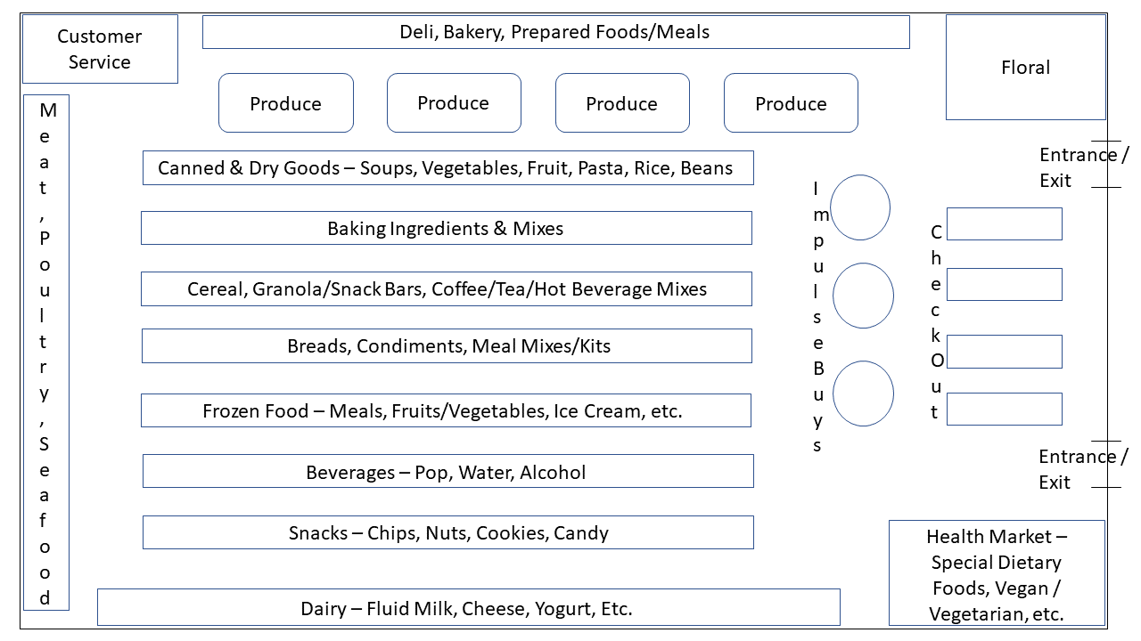
Think about how items are placed in the grocery store. What does the grocer want the customer to do while in the store? It is greatly encouraged to visit local grocery stores. Often the in-person research will be more valuable than online research. If possible, visit 2 to 3 grocery stores or stores with a large grocery section. Typically, visiting at least one mainstream/large grocery store and one specialty grocery store is recommended to provide multiple perspectives and show the breadth of products and categories.
Compile and evaluate all of the market and grocery store research on the
. Spend time considering what all of the research means for your new product concept. Make sure your new product is a good idea. Modify or change your idea if the market and grocery store research is not favorable.

12

New Product Concept Market and Grocery Store Research Worksheet

New Product Concept Information
1. Please provide a brief description of your new product concept or concepts. Try to limit your team’s plans to not more than two ideas. The faster you decide on a single new product concept, the quicker you can get started with formulation. If you do want to pursue two ideas, you will need to provide market research on both.

2. What unique ingredients will you need, if any?

3. Will any of the ingredients be cost-prohibitive?

4. What unique equipment will you need for processing?

5. Any allergens of concern?

6. Any nutritional compositional concerns (fat, cholesterol, sodium, sugar, etc.)?

7. How will your new product concept fit with current trends? Does your new product concept fit a gap in the market? Please explain how your idea will be defendable based on consumer selling points.

8. What have you found in market research in terms of market size, sales, and growth?

9. Who is your target audience and why (be specific)?

10. What are your direct competitors?

11. What are your indirect competitors?

12. Before you conduct grocery store research, where do you think your new product be found in the grocery store (what aisle, with what products)?

Grocery Store & Internet Research
Once the new product has been discussed with faculty, make a trip to one or two grocery stores to conduct research. In-person research is the best when possible. Online research is also valuable, especially in terms of finding regional products.
13. First, look in the grocery store location you envision your new product being sold and fill out the table below with the products you find. Be specific – include brands, flavors, sizes of containers, and prices. Taking photos of products can be very helpful.
Grocery Store: | Location in Store:
Brand | Flavor | Description | Size | Price | Additional Information
Grocery Store: | Location in Store:
Brand | Flavor | Description | Size | Price | Additional Information
Grocery Store: | Location in Store:
Brand | Flavor | Description | Size | Price | Additional Information
Internet Site: | Location in Store:
Brand | Flavor | Description | Size | Price | Additional Information
Internet Site: | Location in Store:
Brand | Flavor | Description | Size | Price | Additional Information
14. Next look in other grocery store areas you think similar products could be found. Add a new location to the table and describe products you find in other pertinent parts of the grocery store.
15. Search the internet for similar products and add them to the table above. Then answer the following questions.
16. Did you find your product concept or something similar? If so, describe it and include the location.

17. After looking at various grocery store locations, does your product placement still make sense? If not, where would the new product placement be? Explain your answer.

18. Does the product category appear small, crowded, or somewhere in between? Justify your answer.

19. Does the product category appear inexpensive, varied, or premium? Explain your answer.

20. What else did you learn while conducting research in the grocery store and on the internet?

21. How does what you learned from the grocery store research modify your new product concept? Explain your answer in detail.

13

Consumer Concept Testing of the Gold Standard
After you have come up with what you think is the best new food product concept, it is valuable to gather consumer data to confirm the brilliance of your idea and provide feedback to hone in your new product concept. Check out this chapter to learn how to write your own consumer concept test.

Background
Numerous sensory tests are used in the development of new food products. These include Consumer Concept Tests, Attribute Tests (JAR Tests), Simple Difference Tests, and Home-Use Tests (HUT). Consumer Concept Tests gather information on consumer attitudes, likes and dislikes, trends, and consumer reactions to your proposed new product idea. Essentially, it is a way to find out if consumers like your new product concept plus get feedback on concept details.

Objectives
- Survey consumers to gain information to justify your new product idea.
- Gain additional information on product type (for example, fresh vs frozen), flavor and texture profiles, package size, overall product acceptability, and any other product attributes.

Advantages
- Justifies potential product interest before a large investment in development
- Pinpoints specific product attributes of interest
- Cost-effective to screen numerous product ideas and concepts to eliminate outliers
- Will allow for preliminary data on potential marketing and advertising strategies

Disadvantages
- Very new and innovative ideas may be difficult to explain without a product prototype.
- May lose (some) confidentially of company long-term objectives
- Consumers may not be completely honest with their responses.
- General consumers may not be your target market.

Methodology
- It is difficult to pinpoint an exact number of consumers surveyed for a typical Concept Test. As a general course guideline, 100 consumers within your target market would be acceptable.
- You may include demographic questions within your survey. Common questions include age, gender, and frequency of product usage. However, a “prefer not to reply” option should be included with every demographic question.
- Course standards do not allow for participants under the age of 18.
- Surveys must contain company information, contact information, and instructions for survey return.
- Open-ended questions are allowed, but hard to analyze.
- Product attribute questions regarding color, flavor, or texture are encouraged. For example, when asking about a fruit flavor, it may be better to provide a list of flavors and ask consumers to rank instead of an open-ended question about what flavor they prefer.
- Questions concerning product type (e.g. fresh/frozen/vending machine/foodservice), package size (e.g. single-serve/family size/bulk pack), and product placement in a retail grocery store can be included.
- This is your chance to ask for feedback on anything you want to know about your product idea.
- After being approved by faculty, consumer concept tests are typically formatted in Google Forms or SurveyMonkey and are distributed through social media and/or emails.

14

Formulation Design - How to Set Up Experiments and Track Variables
It can be daunting to figure out where to start when taking a new product concept and making it a reality. Your team will need to be smart and use educated reasoning to maximize limited time and resources. This chapter will walk you through the process and help get you started.

Making a Food Concept into a New Food Product – Start with a Plan
- Once a new product concept is decided upon, your team will need a formulation starting point.
- Finding existing formulations and recipes and then modifying and combining them as needed is often the easiest way to start.
- Look up usage levels for ingredients, especially if specialty or industrial ingredients are needed (gums, modified starches, etc.).
- Study the existing recipes, formulations, and processing instructions and look for similarities and differences. Think through ingredient functionality and purpose of processing steps to choose the best starting place(s).

Make 2-3 Starting Formulations
- Convert volume measurements to weights and calculate percent by weight right away. Converting volume measurements to weights can be done by carefully weighing out volumetric measurements of ingredients or by looking at reputable references such as the USDA FoodData Central.
  - Weights -> Percents: Ingredient Weight/Total Weight = % by Weight
  - For Baker’s Weight: % by weight of an ingredient/% of flour weight(s) in formula
  - Converting to weights makes it easier to track variable changes.
  - It also allows additional calculations, especially if targeting a specific nutrient content amount.
  - Plus faculty cannot answer ingredient usage questions without the formulation percents.

- Take notes and record observations while making the formulation and evaluate the finished product in detail.
- Determine which formulation and process worked the best and why.

Decide what changes need to be made to reach the optimum gold standard food product.
- Based on the characteristics of the best iteration and the changes that need to be made, make a list of the most effective variables to test.
- There is not enough time or resources to test each variable, so it is important to think through the system and use educated reasoning to narrow down variables to test.
- Keep cost in mind. If you are using an expensive ingredient, could you use a less expensive ingredient and get almost the same functionality and product quality? It is recommended to make the smallest batch size that works on equipment and is needed for sensory evaluation.
- Once variables are chosen, start testing one variable at a time. It is important to only change one ingredient type, ingredient amount, or processing step at a time to track and understand the results of each experiment.

Adjusting and Tracking Variables
- When adding a new ingredient, research usage levels. Depending on the application, it is often most efficient to test the high usage level first. This is the best way to see and evaluate the functionality of the ingredient. Then the level can be reduced as needed.
- Addition vs. Substitution: When adjusting a formulation, it can either be done by addition or by substitution.
  - Addition is taking the existing amounts of ingredients and simply adding another ingredient. This method dilutes or reduces the percentages of other ingredients. It makes the most sense if the ingredient function is different than other ingredients already in the formula.
  - Substitution takes out all or part of one or more ingredients and replaces that amount with another ingredient. This keeps the amounts and percentages of the other ingredients the same, but it replaces one ingredient functionality with another ingredient functionality. Substitution makes the most sense if the new ingredient has a similar function to another ingredient already in the formula.
  - It can be difficult to decide on addition versus substitution. Think through the formulation and the variable you want to test and then evaluate both options to determine which makes the most sense.

- Track the formulation and processing changes and your detailed observations and results in the lab notebook. Also, use an Excel file to track the formulations. The Excel file tracking will allow easy variable tracking and will save time calculating percentages.

A Formulation Example – Adding Fiber to Pancakes
First, review the formula and think about the function of each of the ingredients. Sometimes functions can be confusing. If this is the case, consider how the pancake would turn out without the ingredient added.
Table 1. Pancake Formulation with Ingredient Functionality
Pancake Ingredients | Percent by Weight | Ingredient Function
All-purpose Flour |  | Gluten Structure (Minimal), Starch Gelatinization
Baking Powder | 2.5 | Leavening
Sugar | 2.1 | Sweetness, Tenderizing (Minimal), Maillard Browning
Salt | 1.0 | Taste
Milk, 2% | 52.7 | Hydrate Dry Ingredients, Flavor
Egg | 8.5 | Hydrate Dry Ingredients, Structure, Maillard Browning
Oil | 2.4 | Tenderizing, Flavor (Minimal)
 | 100.0
Now compare addition and substitution methods of adding fiber to the formula. The goal in this scenario is to add fiber to the recipe to get an excellent source of fiber per serving: (5.6 grams / 110 gram serving). Note that for simplicity we are assuming the fiber ingredient is 100% fiber. This is not normally the case but works best here to illustrate differences.
Table 2. Pancake Formulation with Fiber Ingredient Added
 | Option 1 – Addition | Option 2 – Substitution
Pancake Ingredients | Weight (in grams) | Percent by Weight | Weight (in grams) | Percent by Weight
All-purpose flour | 180.0 | 29.2 | 149.2 | 25.5
Fiber Ingredient | 31.4 | 5.1 | 29.8 | 5.1
Baking Powder | 14.4 | 2.3 | 14.4 | 2.5
Sugar | 12.0 | 1.9 | 12.0 | 2.1
Salt | 6.0 | 1.0 | 6.0 | 1.0
Milk, 2% | 309.0 | 50.1 | 309.0 | 52.8
Egg | 50.0 | 8.1 | 50.0 | 8.6
Oil | 14.0 | 2.3 | 14.0 | 2.4
 | 616.8 | 100.0 | 584.4 | 100.0
In this scenario, deciding between addition and substitution will likely center around the fiber ingredient characteristics. If it is a fiber ingredient like wheat bran or oat bran, the fiber ingredient will function similarly enough to flour for substitution to make the most sense. If the fiber is soluble with low viscosity like inulin or resistant maltodextrin, the fiber ingredient does not have similar functionality to the ingredients listed and addition may make more sense.

Material Balance
- Track the material in the system. This tracking will provide context for ingredient functionality and is necessary for generating the nutrition facts panel.
- Measure and record data throughout the formulation testing, NOT just once the gold standard is reached.
- Measurements include processing loss, moisture loss or gain, and fat loss or gain and will depend on the formulation. The most common material balance measurement is moisture loss through cooking, baking, or dehydrating. It can be as simple as measuring the weight of the product before and after the processing step to calculate water loss.
- See the brownie moisture loss example below.

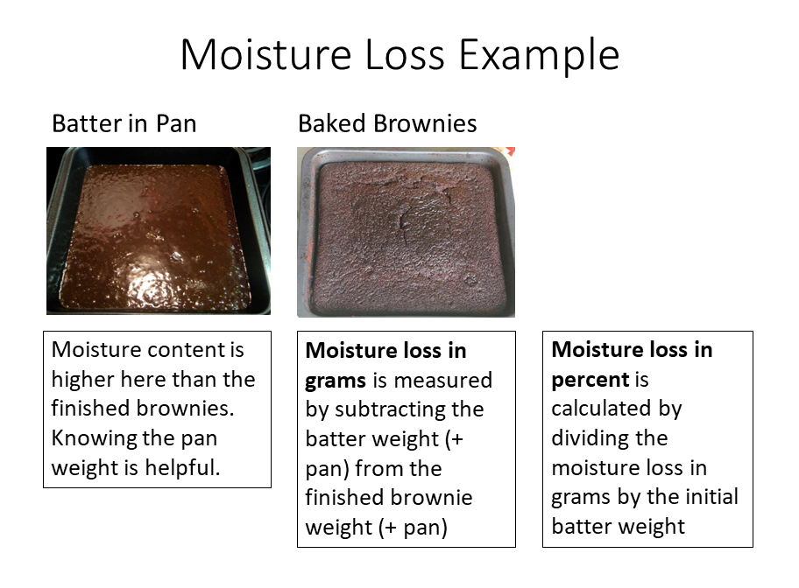

15

Formulation Calculations - Tracking Moisture and Fat Content

Tracking Moisture Content
After working through the material balance example in the previous chapter, you may be wondering why we care about tracking moisture through a process. There are a few reasons why, although tedious, tracking moisture is important.
- It helps us understand what is happening through the process, especially when comparing one experiment to the next.
  - For instance, if the first experiment included raw fruit and the second experiment included frozen fruit puree, how did the initial water content of the fruit (and possibly the particle size) affect the final water content and consistency of the product?
  - If the first experiment included a step to cook a filling on top of the stove for 5 minutes and the second experiment modified that step to cook a filling for 15 minutes, how much water was cooked off in both and how did that affect the finished product texture, color, and flavor?

- Tracking moisture content helps convert liquid ingredients to dry ingredients – like fluid milk to nonfat dry milk or liquid egg to egg powder.
- Lastly, and very important for this course, it allows an accurate Nutrition Facts Panel to be generated in Genesis. The Nutrition Facts Panel serving size is based on the finished product weight.
  - If moisture is lost through cooking or baking, the calories and nutrients are concentrated in the final product.
  - If water is added through processing, it dilutes the calories and nutrients.

- Lastly, tracking moisture through an experiment makes sure you are paying attention to details and observing what is happening during the formulation experimentation process.
Here is an example of tracking the moisture content of ingredients in order to convert from liquid ingredients to dry ingredients. Whenever you are doing formula calculations, it is very important to think through what you know and what you are trying to find. You may need to write it out or draw a picture to help yourself. Then use logic and stop and ask yourself “does that make sense” along the way. For this example, you may want to open your own Excel file and/or write out the calculations to think through the steps. Your layout may look a bit different than what is shown in Tables 1 and 2 and that is okay. Take it slow and make sure you understand each step along the way.

Omelet Formulation Calculation Example – Tracking Moisture and Converting to Dry Ingredients
What you know (or can find out):
- The current formula using liquid ingredients
- The water content (and solids content) of those liquid ingredients
What you want (need) to know:
- Weight of dry ingredients plus the weight of water needed to replace the liquid ingredients
Logic and checkpoints – If you take the water out of the ingredient, you will need less of the dry ingredient.
There are a few ways to calculate a conversion from wet or fully-hydrated ingredients to dry ingredients. Here is an example of converting an omelet formula with fresh/wet ingredients to dry ingredients plus water.
Table 1. Omelet Formulation Made with Fresh Ingredients
Fresh Ingredients Formulation
Ingredients | Batch in grams | % by Weight | Water Content % | Water Content in grams | Dry Weight in grams
Egg
Cheddar Cheese
Skim Milk
Total | 250.0
Table 2. Omelet Made with Dry Ingredients
Converting to Dry Ingredients
Ingredients | Batch in grams | % by Weight | Water Content % | Water Content in grams | Dry Weight %
Dried whole egg powder |  |  | 10 | 4.0 | 90
Dried shredded cheese |  |  | 5 | 1.6 | 95
Nonfat dry milk |  |  | 10 | 0.6 | 90
Water | 172.5 |  | 100 |  | 0
Total | 250.0 |  |  | 6.2

Steps for Calculating the Conversion:
1. Fill out the batch weights and % by weight for your current formula.
2. Water or moisture content of each food can be found in the USDA food database, calculated from an ingredient Nutrition Facts Panel, or from an ingredient specification sheet. (If water is not listed, take the total grams & subtract fat, protein, & carbohydrates to find the water content in grams.)
3. Water content in grams = batch weight x water content %
4. Dry weight in grams = batch weight in grams – water content in grams
5. Convert to dry ingredients or to ingredients with a lower moisture content.
6. List new ingredients & find water content percent for each new ingredient.
7. Find the Dry Weight % for each ingredient = 100% – Water Content %
8. To find the new batch weights in grams, take the dry weight in grams of the original formula & divide by the dry weight % of the new formula.
9. Then find the water content in grams by multiplying the batch weight in grams by the water content %.
10. Find the sum of the water contents in grams. Then subtract the total from the water content in grams from the original formula.
178.7 grams total water minus 6.2 grams water from dry ingredients equals 172.5 grams water
11. Take the difference in water content and add that amount in grams of water to the new formula*.
12. Finish filling out the new formula % by weight and check your work.
*If the original formula contains more or less water than desired, it is okay to adjust the water level and overall moisture content.

Tracking Fat Content
Not all food products will need to track fat content changes, but it is still helpful to understand the process. The main application is for frying food. The other instance where tracking fat content is important is if meat is cooked and fat is rendered from the meat (think frying bacon or cooking ground beef or pork and skimming fat from the cooked meat). The importance of tracking fat changes is similar to that of tracking moisture changes. It explains what is happening through the processing steps and is also important for generating an accurate Nutrition Facts Panel in Genesis.
The example given here is for frying french fries. The difficult thing about tracking fat content through frying is that moisture is lost at the same time fat or oil is picked up.

The same guidelines apply here.
Whenever you are doing formula calculations, it is very important to think through what you know and what you are trying to find. You may need to write it out or draw a picture to help yourself. Then use logic and stop and ask yourself “does that make sense” along the way. For this example, you may want to open your own Excel file and/or write out the calculations to think through the steps. Your layout may look a bit different than what is shown and that is okay. Take it slow and make sure you understand each step along the way.

What We Know or Can Reason:
- If the weight of a food is the same before and after frying, the weight of moisture lost equals the weight of the oil gained.
- If the weight of the food is less after frying, more moisture is lost than oil is picked up.
- If the weight of the food is greater after frying, more oil is picked up than moisture is lost (this is less likely).
Table 3. Frying Worksheet
Data Needed | Percent by Weight | Weight in Grams
Moisture Content Before Frying
Moisture Content After Frying
Moisture Lost During Frying
Weight Before Frying
Weight After Frying
Weight Difference from Frying**
Oil Pick Up =
Table 4. French Fry Example Using a 200-Gram Batch
Data Needed | Percent by Weight | Weight in Grams
Moisture Content Before Frying – USDA Food Database | 83.29% | 166.6
Moisture Content After Frying (measured by moisture balance) | 66.67% | 133.3
Moisture Lost During Frying | 16.63% | 33.3
Weight Before Frying (able to measure the whole batch for this example) | 100.00% | 200.0
Weight After Frying (able to measure the whole batch for this example) | 91.70% | 183.4
Weight Difference from Frying** | 8.30% | 16.6
Oil Pick Up = Moisture Lost During Frying – Weight Difference from Frying | 8.33% | 16.7
Your product may not calculate perfectly like the example above. Determining the values in multiple ways is a great way to verify the results. Weighing the frying pot and oil in the pot at the beginning and end of frying (after the oil is cooled) is a good way to measure oil pick-up for an entire batch.
**If you measure the weight of part of the batch being fried, use the percent difference X the batch weight to get your total moisture loss in grams.

16

Formulation Steps – Order of Addition of Ingredients and Function of Each Step.
Along with tracking ingredient levels and changes through testing, it is equally important to think about the order of ingredient addition and the function of each processing step.

Formulation Steps – Where to Start
Think through the processing steps to make a food. What is the function of each step? Does the order of the steps matter? To help answer these questions, think about what would happen if all of the ingredients were mixed together in one step. Need terminology to help describe the process? Check out the Common Processing Steps table below.
Table 1. Common Processing Steps
Processing Method | Definition | Example(s)
Baked Products:
Creaming | Mixing fat and sugar together vigorously to create an air-in-fat foam | Shortened Cakes and Cookies
Beating | Very vigorous agitation of food mixtures using an electric mixer at high speed or a wooden spoon to trap air and/or develop gluten or an emulsion | Shortened Cakes, egg white foams like in Angel Food Cake
Stirring/moderate mixing | The gentle blending of ingredients when trapping of air and development of gluten are not necessary | Muffins, various quick breads
Folding | Very gentle manipulation used to bring batter up from the bottom of the mixing bowl while incorporating dry ingredients or another batter, all without releasing air from the foam | Angel food cake, soufflé, chiffon cake
Cutting In | Process of cutting solid fats (generally mixed with flour) into small pieces using a pastry blender | Biscuits and Pastry
Kneading | Folding over a ball of dough and pressing it with either the fingertips or the heels of both hands, depending upon the amount of gluten needing to be developed and the ratio of ingredients | Biscuits, Yeast Bread, Pizza Crust
Size Reduction:
Cutting/Chopping | Reducing the size of an ingredient to medium to small pieces | Fruits, Vegetables, Nuts
Grinding/Milling | Reducing the size of a typically dry ingredient to a very small piece or powder | Grains, Nuts
Processing or Blending | Reducing the size and mixing ingredients together, typically with a food processor or blender, to create a liquid or paste | Fruits, Vegetables, Juices, Nuts, Peanuts
Table 2. Common Processing Steps Cont.
Shaping:
Rolling/Laminating | Flattening a dough to a given thickness, potentially layering dough and fat layers together to laminate for a flaky baked product | Pizza crust, Biscuits, Fondant
Cutting or Pressing Shapes | Using a set shape to form a dough, could use a cutter, press, or pan | Sugar cookies, Oreos, Tortilla Chips, Potato Chips
Extruding | Pressing a dough or batter through a tube with a specifically shaped opening | Pasta, Spritz cookies, Sausage & Hot Dogs
Molding | Using a specific 3-D shape to form a coating and/or dough | Candies with fillings such as peanut butter cups and peppermint patties
Coating | Adding a layer to the outside of a food; the layer could be made up of dry ingredients, wet ingredients, or a melting coating that will set upon cooling | Cheetos, Peanut Butter Balls, M&Ms
Mixing:
Hydrating | Mixing of ingredients with the main purpose of water hydrating dry ingredients to get functionality from the dry ingredients | Hydrocolloids, Leavening, Gluten Development
Shear / High-Speed Mixing / Emulsifying | Mixing of ingredients with the purpose of particle size reduction and/or emulsion formation | Salad Dressings
Homogenizing | Processing a liquid under pressure with the goal of particle size reduction to inhibit separation | Milk, Beverages
Water Separation:
Dehydrating | Removal of water from a food, typically slowly using heat and forced air | Fruits & Vegetables
Centrifuging | Separation of particles based on density, often a liquid separated from a semi-solid | Fruit Purees
Physical Pressure | Using physical pressure to squeeze out free water, often using cheesecloth | Cheese, Vegetables
Straining | Using a filter to remove solids from a liquid. The filter size affects the separation and can include cheesecloth and finer filter paper | Apple Cider, Tea, Coffee
Physical/Chemical Reactions:
Fermentation / Enzyme Reaction | Allowing beneficial bacteria, yeast, or enzymes to convert food through controlled breakdown, production of acid, alcohol, and/or carbon dioxide | Sauer Kraut, Yogurt, Yeast Bread, Soy Sauce
Protein Coagulation | Adding an enzyme, salt, acid, physical agitation, or heat to cause proteins to change shape and become less soluble | Cheese, Tofu, Egg White Foams, Cooked Eggs, Cooked Meat
Heating:
Cooking | Heating with a direct heat source, often with a liquid present, typically on the stovetop in a conventional kitchen | Soups, Gravies, Pudding
Baking | Heating in an oven, typically referring to baked products | Cookies, Brownies, Cake
Roasting | Heating in an oven, dry heat method | Chicken, Nuts
Frying | Heating in liquid oil for efficient heat transfer | French Fries, Chicken Nuggets, Funnel Cakes
Cooling/Freezing:
Refrigerating | Cooling a food product to under 40 degrees Fahrenheit | Various
Freezing | Cooling a food product to ~ 0 degrees Fahrenheit, converting water to ice in the food, speed of freezing affects product quality | Various
Next think about where the water is added or removed in the system and what ingredients need to be hydrated to function fully in the food (gums, gluten proteins, leavening, protein powders, etc.).
- Is there enough water in the system to hydrate all of the ingredients like in a beverage?
- Is there limited water in the system leading to minimal hydration of ingredients like in cookies (where often the only water is from the water in the eggs)?
- Is it somewhere in between?
- How much sugar and/or salt are in the system? Both pull water more than other ingredients.
- Consider if the water-containing ingredients need to be mixed with the dry ingredients that need the most hydration first. For instance, gums often need to be mixed with water first before being mixed with other ingredients.

Flow Diagram Starting Point
Once the processing steps have been determined and tested with parameters set (time, temperature, speed, etc.), your team will construct a flow diagram based on the processing steps (not necessarily the equipment). This is helpful as a transition step to processing to determine larger pieces of processing equipment.
As an example, consider the processing steps needed to make a chocolate chip cookie. Here is a typical set of instructions for a chocolate chip cookie recipe modified from Nestle Toll House :
Step 1.
Preheat oven to 375° F.
Step 2.
Combine flour, baking powder, and salt in a small bowl. Beat butter, granulated sugar, and brown sugar in a large mixer bowl until creamy. Beat in eggs and vanilla extract. Gradually add in flour mixture. Stir in chocolate chips. Drop by rounded tablespoon onto ungreased baking sheets.
Step 3.
Bake for 9 to 11 minutes or until golden brown. Cool on baking sheets for 2 minutes; remove to wire racks to cool completely.
Think about the flow diagram that would be constructed from the processing steps for the cookie. Then read through the flow diagram shown below. Do you see how the recipe instructions were converted to a flow diagram? From here, you can construct a flow diagram for your new food product.
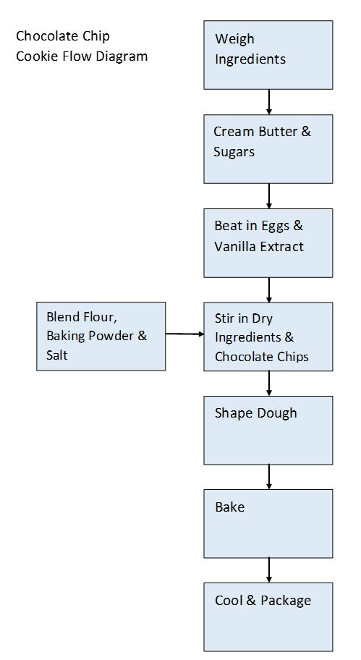

17

Using Genesis Software to Generate Nutrition Facts Panels
Generating a Nutrition Facts Panel is a great way to analyze the macronutrient, micronutrient, and calorie content of your new food product. The Genesis software program (and any other Nutrition Facts Panel program) is only as good as the information that is inputted, so it is important to pay attention to detail and be as accurate as possible on ingredient composition, moisture change, and possibly fat change.

Helpful Resources for Nutrition Facts Panels
- FDA Standard Reference Sizes are important to know when setting a serving size for your product. A serving needs to be within the range of 50-200% of the Reference Amount Customarily Consumed (RACC). More details are included in the 21 CFR 101.9(b)(2)(i).
- FDA Requirements for Nutrient Content Claims are important if you want to make nutrient content claims on your product package. It is often not just about the nutrient, but also about the ingredients and overall nutritional profile of the food.

Using Genesis

Adding Ingredients
- Look through your ingredient list and check out the Genesis ingredient database. Any ingredients in your product that are not in the database will need to be added into Genesis before you start building your product in the system.
- Start a new ingredient. Name the ingredient specific enough (possibly including a brand or company name) so you can find it later. Then input the weight (quantity) of the ingredient based on the nutritional information you have. If the nutritional information is from a specification sheet, the weight is typically 100 grams. This is not the weight of the ingredient in your product.
- Next click on the Nutrient tab and input all of the information you have. Carefully scroll through all of the inputs including vitamins and minerals.
  - Make sure Total Sugar and Added Sugar are both inputted if applicable (needed for the new Nutrition Facts Panel).
  - Add the Fiber content in both prompts (one is for the old Nutrition Facts Panel and the other is for the new version).
  - Add water content. This is the total weight of the ingredient minus the macronutrients.

- When you are done inputting the ingredient components, click “Check Data”. All but the fat content should be green confirming that macronutrients have been added correctly. Make corrections as necessary. Click Save before adding another ingredient or starting a new recipe.

Starting a New Recipe
- Start a new recipe or formula. Save the recipe with an identifiable name to find in the database.
- Include a serving size based on your product weight and the RACC.
- Search for ingredients and choose options that are closest to the ingredients you are using. Then add the amount of each ingredient in grams.
- Adjust yield for moisture, fat, and/or batch loss by clicking “Edit Yields”. Input losses in grams, not percent.
- If moisture and/or fat has been gained through steaming, cooking, or frying, water and/or oil will need to be added to the recipe as ingredients with amounts added in grams.
- Next, check your inputs by clicking “Reports” and then “Spreadsheet”. This spreadsheet will show all the ingredients in your product per serving. Scroll through the nutrients to make sure all are reasonable and there are no glaring mistakes or missing nutrients.
- Return to the recipe and click “View Label” to generate your product’s Nutrition Facts Panel.
- Use the “Edit Label” feature to make adjustments to the label and add in the serving size information.
- Review the results
  - Often all allergens are assumed by default, but that does not mean your product somehow contains all eight major allergens. Please edit accordingly.
  - Serving sizes may need to be modified, especially if a nutrient content goal was not reached.
  - Only use the updated Nutrition Facts Panel label format if all ingredients include added sugars and have fiber content based on the updated guidelines.

- Once the Nutrition Facts Panel has been reviewed, it can be exported by right-clicking on the image and choosing export as image to file, and saving the image as a png or jpeg file. Do not screenshot the Nutrition Facts Panel because image resolution will be lost.

Key Reminders
- If the Nutrition Facts Panel does not make sense, something is wrong. Check the ingredients and your numbers.
- Take into consideration what happens through processing, whenever possible, as much as possible.

18

JAR Attribute Testing

Background
Numerous sensory tests are used in the development of new food products. These include Consumer Concept Tests, Attribute Tests (JAR Tests), Simple Difference Tests, and Home-Use Tests (HUT). Attribute Tests gather information on the acceptability of individual attributes for optimization of your formula for your new product.

Objectives
- Gain consumer feedback on the intensity of specific sensory attributes
- Use consumer feedback on specific attributes for the optimum formulation of your new product
- The optimum formulation will lead to better product acceptance.

Advantages
- Evaluate multiple attributes including size, color, tastes, flavors, and textures with a single test
- Simple and easy to design
- Can be used throughout the development process to optimize product attributes

Disadvantages
- May need a large number of judges because of variation within consumer ratings
- Reformulation based on one attribute may change the ratings and acceptability of other attributes.
- Some consumers may have a hard time blending intensity ratings and liking scores.
- The use of Just About Right Tests, Just Right Tests, and Ideal Level Tests are controversial in the sensory world because of the blend of intensity and liking scores.

Methodology
- As a general course guideline, 30-40 consumers within your target market would be acceptable. In a company setting, 100 consumers may be required (depending on product complexity).
- You may include demographic questions within your survey. Common questions include age, gender, and frequency of product usage. However, a “prefer not to reply” option should be included with every demographic question.
- Course standards do not allow for participants under the age of 18.
- Course standards require the use of 7-point JAR scales with too small, not nearly enough, too light, etc. being scaled on the left-hand portion of the scale and too large, much too much, too dark, etc. being scaled on the right-hand portion of the scale. Most often, category scales are used with a score of 4.0 representing Just-About-Right in the center of the scale.
- Include a scale for any and every attribute of interest including size, color, tastes, flavors, and textures.
- Faculty must approve your JAR Attribute Test before the sensory panel can be conducted.
- Analysis – summarize the frequency of responses within each of the categories on the 7-point scale.
- Seventy-five percent of scores must fall in the 3.0, 4.0, and 5.0 categories for the attribute to “pass” and be considered acceptable. Note: This is not calculating a mean by averaging all responses.
- Scale attributes that have less than 75% of 3.0, 4.0, and 5.0 scores need to be addressed. Reformulate your product to improve these attributes and then repeat JAR Attribute Testing as needed.

19

Industrial Ingredients – Purpose, Sourcing and Conversion
Here is an explanation of why we start with grocery store ingredients and then convert them to industrial ingredients. Industrial ingredients are requested from food companies and not purchased from the grocery store. Some industrial ingredients are quite similar to grocery store ingredients. Other industrial ingredients have variations in composition, moisture content, and functionality. It is important to understand the differences and that converting to industrial ingredients takes time and planning.

We start with grocery store ingredients to produce your gold standard product due to:
- Speed of getting (most) ingredients
- Understanding the ingredient functionality of fresh ingredients before using industrial ingredients
  - Real egg to powdered egg
  - Butter to butter powder or butter-flavored shortening
  - Unmodified starch to modified starch
  - Fresh flavors to liquid flavors (helps determine desired profile)

- Exceptions to starting with grocery ingredients (or instances when you may move to industrial ingredients before processing):
  - When your product needs functionality you cannot get with grocery ingredients such as hydrocolloids in ice cream
  - When the grocery store ingredient is expensive and an industrial ingredient is readily available

Moving to Industrial Ingredients – typically done at the end of the formulation section into the beginning of the processing section – has pros and cons.

Pros:
- Typically receive free samples from ingredient companies (or we just cover shipping) – this is good for your course fees!
- Most industrial ingredients come with specifications/nutrition information/certificates of analysis.
- Often industrial ingredients give you more functional options than what can be sourced in the grocery store.
  - Examples include native starch to a variety of modified starches, pure pectin, low-heat and high-heat non-fat dry milk, various cocoas, chocolates and coatings, fruit purees, etc.

Cons:
- Takes longer to get industrial ingredients (have to request each ingredient from the supplier and we can be a low priority)
- There can be limits on sample sizes.

20

Industrial Ingredient Worksheet
The sooner you submit the worksheet, the quicker industrial ingredients can be sourced.
- Start with course preferred suppliers, look in the Food Master (publication) and search the internet for ingredient suppliers.
- Provide multiple sources if you have them.
Current Ingredients | Current Batch Weight (in grams) | Current Percent by Weight | Functionality of Ingredient | Proposed Industrial Ingredient & Source (Company, product name, etc.)

IV

Processing

To Start the Processing Stage:
It is important to acknowledge that there are a variety of components covered in Processing. Those components are not necessarily linear steps and can be grouped into the following categories:
- Scale-Up Logistics & Planning
- Equipment & Flow Diagram
- Analytical Testing
During this period your group will be responsible for perfecting your processable formula. This will include moving to (more) industrial ingredients. You will scale up your formula in the laboratory and under plant conditions. Your group will be involved with processing and process development, food safety and quality research and testing, effects of storage, and issues pertaining to handling, packaging, and shipping.

21

Components of Processing and Where to Start
Processing can be broken into three main parts. These parts overlap and may need to happen simultaneously during processing, so it is helpful to start on each part and plan tasks accordingly.

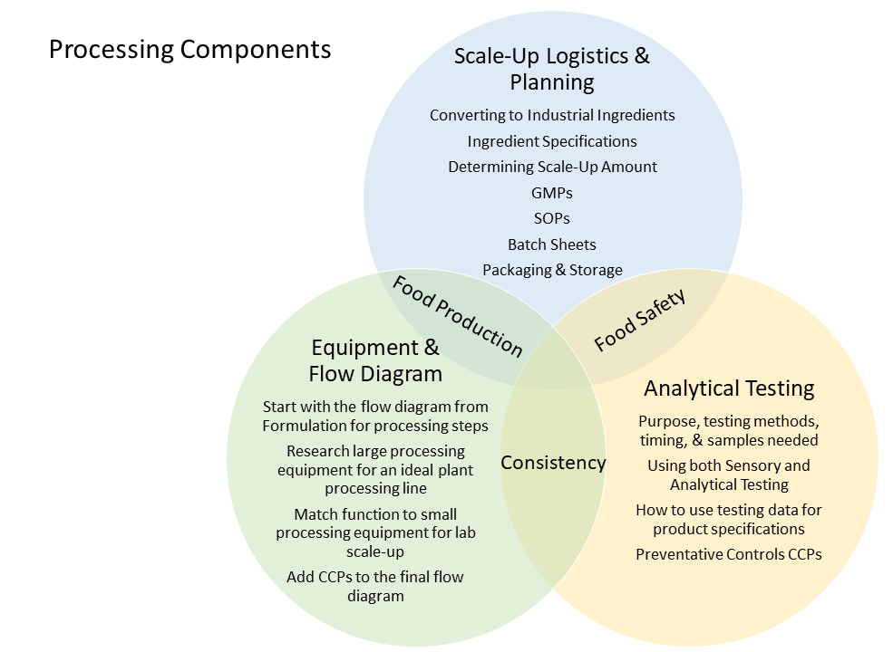

At the end of Processing, you will have completed the following components:
- Formulations – Gold Standard and Scale-up Formulation with Industrial Ingredients
- Analytical Testing Methods used, the purpose of test, method, and results
- Comparison of (Analytical and Sensory) Test Data from Scale-up to your Gold Standard
- Scale-Up Amount Calculated & Justified
- Equipment Needed for Large Scale Production – equipment photos and functionality
- Equipment Needed for Small Scale Lab Production – equipment settings and functionality
- GMPs, SOPs, and Completed Batch Sheets
- Ingredient Specifications
- Preventative Control Hazard Analysis and Flow Diagram with Preventative Controls Included
- Scale-up Summary – How did it go, successes, problems, etc.
Details of many of the components are included below as a reference. Keep in mind that you may not work in the order listed. This is meant to give you a scope of the tasks in an order that could likely be used.

Step 1. Gold Standard – Collect Analytical Data
- What are the most important characteristics of your product?
- Analytical Equipment typically available in-house includes:
  - Water Activity Meter
  - Moisture Balance
  - pH Meter
  - Refractometer
  - Hunter Colorimeter
  - Texture Analyzer – know what textural attribute you want to measure
  - Bostwick Consistometer
  - Ring Spread Test
  - Brookfield Viscometer
  - Penetrometer
  - Seed Displacement
  - Density (calculation)

Step 2. Convert to Industrial Ingredients
- Going away from fresh ingredients like milk, eggs, and raw fruits & vegetables
- If a fresh ingredient is key to your product, you will need to collect data to show that importance.
- Work on your industrial ingredient list due at the end of formulation/beginning of processing.
- The process of ordering industrial ingredients takes time, so try to be patient.
- See Industrial Ingredients Chapter and Worksheet in Formulation for more information.

Step 3. Production Equipment, Scale-Up Equipment, and Flow Diagram
- This covers a large segment of processing and includes multiple components.
- Production Equipment – equipment you would use in large-scale plant production – search references and the internet for processing equipment photos and videos. If you cannot find exactly what you are looking for, show a similar piece of equipment and explain how it would be modified for your product or sketch the new piece of equipment.
- Scale-Up Equipment – what you will use for scaling up your product on campus. The goal is to match the function of the large-scale equipment chosen with the scale-up equipment that is available.
- Flow Diagram – steps of your process written out in block diagram format. Take your initial flow diagram from Formulation and convert it for large-scale / plant production equipment and processing steps.

Step 4. Prepare GMPs, SOPs, & Batch Sheets
- GMPs: Read the cGMPs in 21 CFR Part 117. Then write your product-specific GMPs.
- SOPs: Standard Operating Procedures are detailed instructions for each step of your process. Think about handing the SOPs to a plant worker. Would they be able to make your product to your standards based on the instructions laid out in the SOPs?
- Batch Sheets: documents used in plants to monitor processes to ensure that the process is being carried out correctly and as a historical document that can be reviewed if there are any questions about the process in the future.
  - For each step in your process (flow diagram), there should be a section in your batch sheet to document the step.

Step 5. Ingredient Specifications – can think about this in terms of what ingredient (quality/characteristics) you would (and would not) accept into a plant to make your product.
- Industrial Ingredient Specifications can be used.
- If you are using a grocery store ingredient:
  - Find a comparable industrial ingredient specification sheet
  - Or – use the Nutrition Facts Panel and/or the USDA FoodData Central to create your own ingredient specification.

- Use references to set microbial specifications.

Step 6. Conduct a Hazard Analysis using Preventative Controls Methodology
- Conduct a Hazard Analysis using the Preventative Controls for Human Food manual formatting.
- Assume strong prerequisite programs and that the plant is specific to your product.
- Focus on pathogens, allergens, and metal fragments.
- Determine Preventative Controls for your process and product. Also, determine what other concerns can be managed through Supplier Programs and/or Prerequisite Programs.
- Discuss the hazard analysis and Preventative Controls with faculty
- Add the Preventative Controls to the flow diagram.

Step 7. Packaging & Storage
- Think about your product characteristics.
- What functionality does your product packaging need to have to protect your product and have a positive impact on shelf life?
- Research packaging types to choose the ideal packaging material(s) for your product. More information about packaging will be included in the Commercialization section, but it does not hurt to start researching packaging materials as you have time.
- Discuss packaging needs for the scaled-up product (may not be the same as your ideal packaging).
- Need refrigerator or freezer space for the scaled-up product? Check with faculty to coordinate space.

Step 8. Scale Up
- The actual scale-up will take one to two lab periods. During this time, your team will make enough product for testing needs.
- It is important to have all of the details and procedure parameters figured out before scale-up occurs because typically there are only enough time and resources to scale up once.

Step 9. Analytical Measurements
- Your main goals are to:
  - Compare your gold-standard product to your scaled-up product
  - Collect data related to shelf-life determination (pH, water activity, color, etc.)
  - Collect data – in-process and finished product – to provide guidance for process and finished product specifications.

- Refer to Step 1 for the analytical equipment list.

22

Analytical Testing
The purpose of analytical testing is to reduce the number of sensory panels needed by measuring sensory attributes with equipment and to measure attributes needed for product specifications. Analytical testing also can be used to determine shelf life and shelf stability parameters. Make a plan for analytical testing based on key product characteristics/attributes.

1. Determine what attributes of your food are most important for food safety, quality, and consistency.
- It is too expensive and time-intensive to test every attribute of a food product, but enough testing needs to be done to understand product characteristics and to maintain product safety and quality.
- Typically 4-6 analytical tests are run per new food product.
- Look at the Analytical Testing Equipment available in your food lab.
- Common Analytical Equipment
  - Water Activity Meter
  - Moisture Balance
  - pH Meter
  - Refractometer
  - Hunter Colorimeter
  - Texture Analyzer – know what textural attribute you want to measure
  - Bostwick Consistometer
  - Ring Spread Test
  - Brookfield Viscometer
  - Penetrometer
  - Seed Displacement
  - Density (calculation)

- Next, determine the best way(s) to test the key product attributes.
- Discuss options with faculty as needed.
A Note on Microbial Testing – Often food labs do not have microbial testing capabilities and rely on available research and knowledge to set kill steps in-process and finished product specifications. If specific microbial testing is needed for a new product, teams can inquire with related food microbiological labs on campus to see if testing can be conducted.

2. Timing of Testing: Think through the timing of testing or when the product iterations that need to be tested will be made.
- The gold standard product will need to be compared with the scaled-up industrial product.
- Some in-process testing may be needed.
- Typically finished product testing is best when the product is fresh, but testing at the same time for each product is more important.
- Analytical testing also can be used for shelf-life testing and to compare the preparation or storage methods of a product.

3. Sample Amount Needed: When in doubt, more samples are better than fewer. Testing multiple batches is advised when possible, but we realize it is not always feasible with limited time and resources.
- At least three samples from the same batch or iteration are needed for testing such as viscosity, color, moisture, and water activity. This will help reduce variability across a batch.
- Seven to ten samples per batch or iteration are typically needed for texture analysis. More is needed if there is considerable variability of texture in the product (think crisp and crunchy products).
- Consider the sample available for testing and the order of testing when the sample amount is limited. Texture analysis typically needs whole product. Water activity, moisture content, and pH need homogenous and often mixed/ground product.
- More samples are almost always needed at the beginning of analytical testing to set test parameters. This is especially true for the texture analyzer because testing parameters will need to be set specific to your product.

4. Analytical Testing Plan: After working through steps 1-3, compile your testing needs into the table shown below. Edit the table as necessary for your product testing needs. Review your testing plan with faculty before you start.
Product Characteristic | Testing Method/ Equipment | Testing Parameters | What the method actually tests | Number or Amount of Samples needed | Sample time (s) | Sample conditions
Ex. Chewiness | Texture Analyzer | 3 Point Bend Rig + Knife | Downward force and distance | At least 10 per variable or iteration | Same day as baked – for gold standard and scale-up product. Test 1st (then use the broken product for other sampling) | Whole, 6-7 cm in diameter

23

Scale-Up Expectations and Value

As you get ready to scale up, it is important to take a moment to discuss why scale-up is an important part of processing.

Objectives of Scale-Up
- Practice detailed planning before scale-up
- Experience with different, sometimes larger, equipment
- Produce samples for Home Use Tests, shelf-life/abuse testing, and final board meeting

Preparation Required
While the actual scale-up will only be one or two lab periods, it will take weeks to plan. A successful Processing section is tied to detailed and thorough planning. Your team must work through equipment selections, preventative controls, and scale-up planning documents including GMPS, SOPs, and a batch sheet. Testing industrial ingredients and new equipment also will need to be done resulting in a final industrial formula with specific processing parameters. It is also important to plan where and how to store your scaled-up product before you start.

One Chance
You are really only going to get one chance to scale up in the course, and you may only get once or twice to be able to scale up in a large processing facility, as well. This is especially the case if you have to stop the line or stop production of a day-to-day product to test run your new product. That time could be very limited so making sure all of the pre-work is done with attention to detail and potential problems or setbacks have been considered are critical to make that scale-up time count.

Product Samples Needed
The amount of product made during scale-up will be the amount needed for the Home Use Test, analytical testing, and shelf-life/product abuse testing. If your product has a 6-week shelf life or greater, more product will be made for the final board meeting and poster presentation. The amount needed for scale-up will vary based on the product but is typically still going to be a lab-scale amount. The goal is to make a bigger batch than what your team has previously made with equipment that has the same or very similar functions as the large-scale plant equipment.

Learning from Experience
Each time you go up in the size of equipment and each time you change the type of equipment and what controls you have over that equipment, your product characteristics have the potential to change. During scale-up it is likely that your team will not have as much processing control as with previous small batches. You will learn how that changes your product (possibly more waste, less uniformity, etc.). Most of the changes are not going to be significant, but some may be and it is important to know and understand these changes. For instance, if the moisture content of a cracker increases from 8% with small-scale processing to 12% with scale-up processing, the texture of the cracker could change significantly. A crisp cracker could become stale and tough with just this small moisture change. The processing parameters would have to be adjusted to produce an acceptable, lower moisture cracker. Knowing what characteristics are critical for your product will allow you to make quick changes while scaling up.
Here is a checklist of items that need to be completed and approved before you will be ready to scale up.

Scale-Up Preparation Checklist
- Large Equipment determined
- Small Equipment chosen (based on large equipment function) and tested
- Updated Flow Diagram approved
- Preventative Controls Hazard Analysis conducted and discussed with faculty
- GMPs approved
- SOPs approved
- Batch Sheet approved
- Industrial ingredients tested, industrial formula finalized
- New equipment tested (can be a small batch)
- Scale-Up Amount determined
- Time and Equipment scheduled
- Ingredients ordered and secured
- Storage of scaled-up product determined

To-Do List After Scale-Up
- Measure scaled-up product attributes to compare to the gold standard and to set final product specifications
- Write Home Use Test, get approval, send product out safely to consumers
- Start shelf-life and/or abuse testing

24

Processing Equipment Considerations

It is time to figure out how to make your product on a large scale!

The goal is to think about the process which includes the function of each step (why is the step in the process and how does it affect the ingredients) and what equipment is needed to perform that function. Each time equipment is scaled to a different size (kitchen equipment, lab equipment, pilot plant equipment, plant equipment), the equipment will function slightly differently, which can have small or large effects on the finished product. These effects can be due to small differences in how the equipment works, how full the equipment is, differences in volume to surface area ratios, and more. It is best to be prepared for changes and adjustments when scaling up equipment.
The core thought process when updating the flow diagram and choosing equipment should be the function of the processing steps.

Start with the flow diagram from Formulation and update for the industrialized formula.
To keep the functionality of each step in mind, start with the flow diagram from the Formulation stage. Update the flow diagram once the formulation is converted to industrial ingredients (this may need to be updated more than once while working through other processing steps). These updates may be minimal or considerable depending on the ingredient changes (wet ingredients to dry ingredients, real ingredients to flavors, etc.). See the Food Safety Preventative Controls Alliance Preventative Controls for Human Food manual page A3-5 for a flow diagram example.

Research large processing equipment for an ideal plant processing line.
You will be in charge of designing your processing line on a large plant scale. This may look similar to the small-scale equipment, just with larger pieces of equipment, or it may look considerably different based on small equipment available to you and changes encountered when converting to a continuous process (as opposed to a batch process).

Method/Steps: Design a processing line on a plant scale.
- Use the functions of the processing steps to choose large-scale processing equipment for an ideal plant processing line.
- Use processing equipment references, textbooks, and the Common Types of Food Processing Equipment list shown below to start.
- Then look at other processing equipment images and videos online (How It’s Made videos are very helpful) to find specialty equipment.
- If a new piece of equipment is needed to make your product (most commonly needed for shaping or molding), sketch an image of the needed equipment or find a similar piece of equipment and describe how it would be modified for your process.
- Include conveyor belts and holding tanks as much as possible.
- End with filling and packaging equipment. Consider the filling speed and precision of the chosen equipment.

Common Types of Food Processing Equipment

Size Reduction
- Family of equipment that specializes in reducing fibrous roots, fruits, cooked meats, dry cheese, vegetables, legumes, nuts, and more into smaller sizes for further processing.
- Common types:
  - Angle disintegrators
  - Screw-fed disintegrators
  - Pump fed disintegrators
  - Crushers
  - Shredders
  - Mills
  - Grinders

Molders
- Process of taking a nearly finished product and making it into the desired shape
- Common types
  - Dough Sheeter
  - Bread Molder
  - Confectionary Molder
  - Enrobing Machine

Extruders
- Process that forces food through a small opening called a die to form and shape the materials into a desired shape
- Combines multiple food processing steps into one
- Common types
  - Single Screw Extruder
  - Twin Screw Extruder
  - Pasta Extruder
  - Co-extruder

Homogenizers/Emulsifiers
- Operation that reduced the average particle size and increases the consistency of semi-solid and liquid food matter
- Common types
  - High-Pressure Homogenizer
  - Sonolator
  - Colloid Mill
  - High Shear Mixer

Mixers
- Processing step that combines and disperses two or more components into one another to achieve and maintain a uniform mixture and/or an alteration to the functional or aesthetic qualities of the food product
- Common types
  - Agitation Tanks
  - Paddle Mixers
  - Drum Blender

Baking
- Employs heated air to heat and produce physical and chemical changes in food material, such as texture and/or flavor
- Assists in the preservation of food matter by killing microorganisms and reducing the moisture content.
- Common types
  - Deck Oven
  - Rotary Oven
  - Convection Oven
  - Combination Oven

Frying
- Process of foods being heated in (160 – 180°C) fat or oil to transfer heat directly to food material
- Reduces moisture content, forms a crispy/crunchy exterior, and inactivates microorganisms
- Common types
  - Batch Fryer
  - Continuous Fryer

Blanching
- Employs heated water or steam to reduce the number of microorganisms and inactivate undesirable enzymes that cause spoilage
- Removes excess air from the fruit or vegetable, softens the texture, and improves the overall quality
- Typically done before freezing vegetables
- Common types
  - Steam Blanchers
  - Hot Water Blanchers

Canning
- Process that places food in a sealed can or glass jar that is heated at high temperatures for enough time to preserve the food
- Creates products that are commercially sterile where all pathogenic, toxin forming, and spoilage organisms are killed
- Allows food to be stable at room temperature
- Retort Canning is the main example
- Hot Water Cooker is an option for some foods, but does not provide the same level of heating/microbial reduction as retort canning (typically acidic, high sugar, or high salt foods)

Pasteurization
- Food processing step where food materials are placed under moderate temperatures to inactivate pathogenic microorganisms
- Typically, pasteurization produces food products with limited shelf lives and sterilization produces food products with extended shelf lives
- 3 major types
  - Vat pasteurization
  - HTST
  - UHT

Drying
- Process that removes water from a food with the intention of producing a solid food product with low water content
- Increases the shelf life of food products by reducing water content which inhibits or slows microbial growth and enzyme activity
- Common Types
  - Convective Dryers
  - Vacuum Dryer
  - Drum Dryer
  - Spray Dryer
  - Freeze Dryer

Freezing
- Process that lowers the temperature of a food product to -18°C or below
- Decreases the enzymatic action, as well as slows the metabolism of microorganisms, acting as a preservation method
- Common types
  - Blast Freezers
  - Plate Freezer
  - Cryogenic Freezer
  - Belt Freezer
  - Fluidized Belt Freezer

Refrigeration
- Process that lowers the temperature of food to below 40°F
- Typically encountered as a walk-in cooler

Belts
- An important component in a food processing line transporting food throughout the factory
- Common types
  - Plastic Modular
  - Solid Flat Belt
  - Wire Mesh

Hoppers
- Used for storage, as well as the main component of metered transfer of food components
- Can be equipped with jacketing to help heating and cooling, or equipped with special attachments based on the food product

Filling Equipment
- Final process before final packaging that places the food products created into the proper package. Packaging comes in all different shapes and sizes, with different filling equipment necessary for all the different food products, as well as all the different packages available
- Common types
  - Volumetric Fillers
  - Net Weight Fillers
  - Overflow filling machines
  - Cup Machines
  - Centrifugal Machine Counting

For more information, check out the article, Overview of Food Processing Equipment. The content above is adapted from the same article by Romina Ronquillo.

Determining Lab-Scale or Small-Scale Equipment Based on the Large-Scale Equipment

Match the function of the large-scale equipment to small processing equipment available for lab scale-up. Think through the processing steps and functions of equipment chosen for plant production. Then consider the small processing equipment available. Make the best fit matches of functions of steps to equipment available to scale-up. When your team is ready, review your large-scale and small-scale equipment with faculty. Then test the small-scale equipment to determine the effectiveness and optimal run parameters (time, speed, temperature, etc.).
It is important to note that choosing lab-scale equipment is not necessarily about what is the easiest or most convenient. It is about matching functions of the equipment so that the lab scale-up is as close as possible to large-scale production.

25

Good Manufacturing Practices

Purpose

Methodology
Read through the Current Good Manufacturing Practices in the Code of Federal Regulations Title 21 Part 117. Then write Good Manufacturing Practices for your product and process. Focus on the GMPs that are most relevant. Frame your GMP to fit a plant-scale operation. Your GMPs also will need to be followed as close as possible during scale-up in the lab.

Potential GMP categories include, but are not limited to:
- Building and Facilities
- Receiving
- Sanitation
- Food Handling and Processing
- Packaging
- Storage
- Personnel and Training
  - Cleanliness
  - Handwashing
  - Jewelry
  - Gloves
  - Hair restraints
  - No food in processing area

26

Writing Standard Operating Procedures for Your Product

Purpose
Standard Operating Procedures (SOPs) and Sanitation Standard Operating Procedures (SSOPs) are written and implemented to provide instructions for tasks that are done regularly as part of food receiving, storage, production, and testing. These instructions are needed to make sure there is consistency in production and to reduce hazard risks.

Instructions
Using the reference examples given, list all of the SOPs your product and process would need. Include a short one- to two-sentence description for each SOP in the list.
Then write one full SOP in detail with the format given below (this could be making one component of your product or one unit operation depending on how complex the process is). You can think about an SOP like a detailed recipe that includes the ingredients and amounts (materials) and step-by-step instructions of how the food is made (procedure of how the task is performed). Just add a few more details and the SOP is developed. The one full SOP should be written in enough detail that it could be handed off to another person and that person could successfully complete the task and/or make your product.

Format for One Full SOP
- Title
- Purpose—what task are you accomplishing and why?
- Scope – when and where does this task take place?
- Responsibility—who is responsible for making sure the task is completed?
- Materials—what specific items are needed to complete the task?
- Procedure—what are the steps to the task, in order?
- Monitoring—what checks are in place to monitor or check that the SOP was completed?
- Corrective Action—what steps will be taken if the SOP is not completed correctly?
- Verification/documentation—how will you verify that the procedure was completed correctly and what records will you keep?

Additional References Including Examples
- Cornell Dairy Foods Extension Standard Operating Procedures
- FEED Kitchens Standard Operating Procedure Forms
- Penn State Extension Standard Operating Procedures: A Writing Guide
- UMass Extension Vegetable Program Standard Operating Procedures
- University of Minnesota Extension Standard Operating Procedures (SOPs)

27

Constructing Batch Sheets For Scale-Up

What is a Batch Sheet?
It is a document used in plants to monitor processes to ensure that the process is being carried out correctly. A batch sheet is the documentation used to explain if a process does not go as planned.

Purpose
An SOP provides detailed instructions for a process. Batch Sheets are needed to record exactly what happened during the process. A process rarely goes exactly as planned. Ingredient weights may be off of the formula weights slightly. Equipment conditions, speeds, temperatures, etc. can vary based on batch size or the given day of operation. The batch sheets are the first documents to be reviewed if the finished product does not meet specifications, so the detail and accuracy of the batch sheets are very important.

Method
- For each step or unit operation in your process (consult your up-to-date flow diagram), there should be a section in your batch sheet to document the step or unit operation parameters.
- Your process may need multiple batch sheets depending on the steps and what needs to be monitored.
- Below is a general batch sheet. Construct your batch sheet(s) based on your process and be as specific as possible. In addition to the columns below, you may also need to include data such as time, temperature, pH, RPMs, flow rates, throughput rates, the weight of rework, etc.
- Faculty will need to approve your batch sheet(s) before scale-up.
- The completed batch sheet(s) with all the details of scale-up recorded will be submitted.
Unit Operation | Ingredient | Formula Weight (units) | Actual Weight (units) | Equipment & Conditions | Process Specification | Unit Operation Conclusion, including any variation from your SOP

28

Setting Ingredient Specifications

Purpose
The purpose of setting ingredient specifications is to make sure you get safe and consistent quality ingredients to produce a safe and consistent final product. Your team should have an SOP detailing what to do with an ingredient if it arrives out of spec. Examples include if an incoming ingredient contains an allergen that was not listed on the specification, arrives outside of temperature spec (too hot or too cold), or arrives in dirty or broken boxes or bags, leaking containers, etc.
For example, a warehouse employee calls after receiving a pallet of apples that are in rings instead of being diced. They ask, “You did not get what you ordered, what do I do with this stuff?” You need to have an answer.

Key Points of Setting Ingredient Specifications
- Specifies the quality, safety, and storage of ingredients used in the food product
- Needed for hazard risk assessment and supplier program documentation
- Determines if an ingredient is allowed into your plant or not – what characteristics are most important (what would you reject/not pay for)
- Important to set tight enough specifications to ensure a consistent and safe final product.

Method
- Gather ingredient specification sheets, product bulletins, and/or certificates of analysis for industrial ingredients.
- Use ingredient packaging information and USDA FoodData Central information for ingredients without specification sheets.
- Use references shared below (plus you are encouraged to do further research) to set microbial specifications for those ingredients without them. Think through your process – do you have a strong kill step, is your product ready to eat, etc. These factors will affect the microbial specifications allowed for incoming ingredients.
- Choose the most important characteristics for the ingredients to compile an ingredient specification table. Column headers need to include those shown in the example below (Ingredient, Required Attributes, Preferred Supplier, Microbial Specifications, Receiving Storage Conditions, Potential Allergens or Labeling Concerns) and can include additional columns as needed.
- Include as much detail for each ingredient as is needed to ensure your product will turn out consistently with the quality characteristics expected. Required Attributes may include flavor profile, aroma, color, clarity, texture, particle size, uniformity, or the variation in size that is acceptable.
- The Preferred Supplier column will be filled out related to where your ingredient is being sourced. Suppliers of some ingredients will be very important for consistency and specific attributes. Other ingredients will have more flexibility. For example, granulated sugar can easily be sourced from multiple suppliers without a noticeable difference in quality attributes. It would be difficult to source a flavor from two suppliers and get the exact same flavor profile, so a flavor ingredient specification will need a preferred supplier listed.

Ingredient Specification Table
Ingredients in formulation need to be represented in the following or similar table:
Example Ingredient Specification Table
Ingredient | Required Attributes | Preferred Supplier | Microbial Specifications, Concerns | Receiving – Storage Conditions | Potential Allergens or Labeling Concerns
Guar Gum | Moisture 10-15% |  | APC < 2500 CFU/g | Cool (70 degrees F or below) & dry (<40% Relative Humidity) environment | None
Honey Powder | Powder Moisture 5-15% |  | APC < 5,000 CFU/g, | Cool (70 degrees F or below) & dry (<40% Relative Humidity) environment | None

Microbial Specification References
- Compendium of Microbial Criteria for Food, September 2018 (pdf)
- USDA FSIS Microbiology Laboratory Guidebook
- ICMSF Microorganisms in Food 8

29

Food Safety Plans

Where to Start with Food Safety

It really boils down to what needs to happen to make sure a safe product is made the vast majority of the time. It is hard to plan for everything that could go wrong, but it is important to consider all relevant reasonable risks. You know you can produce a safe food product because your team has done it through the Formulation stage. Now it is time to consider how to ensure that same safety when transitioning to industrial ingredients and a large plant-scale operation.

HACCP or Preventative Controls?

Method
Start with a general conversation in your team about what will be your main hazards or food safety concerns. Then work through the Preventative Controls Hazard Analysis form. As you work through the form, research hazards to determine which are likely enough to be considered.
- Use the Food Safety Preventative Controls Alliance Preventative Controls for Human Food manual as a reference. Chapter 8 and Appendix 3 will be especially helpful.
- To streamline the process, focus on biological pathogens, chemical allergens, and physical metal fragments. It is acceptable to include additional hazards but is not required for this hazard analysis.
- Assume there are strong prerequisite programs in place and your product is the only product made in the plant.
- The most common preventative controls are a heating step and metal detection right before or after packaging, but it is important to consider your process, product hazards, and associated risks.
- If your product does not have a heat step, careful consideration will be needed to ensure no pathogens are present in the finished product. Food safety experts really like kill steps and will ask more questions if your process does not include one. Relying on supplier guarantees for pathogen-free ingredients is acceptable – just make sure that is a feasible plan for your ingredients.
- After completing the hazard analysis, add the Preventative Controls to your product’s flow diagram.
- Have faculty review your hazard analysis.

V

Commercialization
Commercialization is your last strategic objective for product development. This section is about bringing all of the pieces together and making your product ready to sell on grocery store shelves. Commercialization can be tedious with lots of details to document, but these details are important and are needed to ensure success.

30

Commercialization Introduction
During Commercialization, your team will prepare your product for grocery store launch by completing the following objectives.

Objectives
- Confirm product quality produced during scale-up meets consumer expectations with Home Use Test (HUT).
- Define and document your product with Final Product Specifications, Package Label, and the team’s completed notebook.
- Compare and defend the quality of your product using Ingredient Pricing/Suggested Retail Price (SRP) & the Final Presentation.

Key Points
- Your team will need to move faster on paperwork and documents in this section than in previous sections. Attention to detail is critical due to time constraints associated with a successful product launch.
- It is okay to divide tasks and be working on multiple tasks per lab period.
- Make a plan to complete tasks, so you can stay on top of all of the items.

The following is a checklist to help in organizing the work for this strategic objective.
___ Consumer acceptance test (Home Use Test or HUT)
___ Shelf Life/Abuse Testing
___ Final product specifications including packaging materials and specs.
___ Final package with approved Nutrition Facts Panel. All labels and final packages must be approved.
___ Ingredient costs: Determine your ingredient costs and calculate a theoretical SRP based on information provided (model costing including manufacturing costs, packaging, marketing/advising, company profit, grocery store mark-up, etc.) and compare your predicted SRP with a chosen competitive product(s).
____ Professional oral presentation – needs to be reviewed and approved during the lab period before the presentation
____ Notebooks: completed with detailed table of contents – due Finals Week

Timeline
Week 1. Finishing processing scale-up and report, getting home use test written/approved/sent out, and getting shelf-life testing/abuse testing and analytical testing started. Submit ingredient list for pricing.
Weeks 2 & 3. Work on items not yet complete, plus work on final product specifications, packaging materials, and the product label.
Week 4. Work on the final product label, package, pricing, and presentation.
Week 5. Get the final presentation approved and present to the board. Work on the commercialization report.

31

Home Use Tests (HUT)
Home Use Tests (HUT) are the last sensory evaluation done before your product will be launched in the grocery store. It is important to check the liking of attributes and the overall product, along with the willingness to purchase and the price consumers would be willing to pay.

Background
Numerous sensory tests are used in the development of new food products. These include Consumer Concept Tests, Attribute Tests (JAR Tests), Simple Difference Tests, and Home-Use Tests (HUT). Home-Use Tests provide valuable information on product performance in a natural environment before marketing and launch.

Objectives
- Gather real-time consumer data related to product sensory quality.
- Gain additional information on product packaging, serving size, package instructions, product cost, frequency of purchase, and reaction to product claims (gluten-free, vegan, nutrient content claims, etc.).

Advantages
- Allows for product usage under true consumer conditions when compared with CLT’s (Central Location Tests – in the lab, mall, grocery store, etc.)
- Allows for multiple responses if more than one household member
- May allow for sampling of high-fatigue products over time (coffee, spicy foods, etc.)
- Allows for the opportunity to test a product in different market segments across the country

Disadvantages
- Expensive
- Limited or no control over how the product will be used by the consumer
- Traditional low questionnaire return rates… may be as low as 25%
- Loss of confidentially

Methodology
- An ideal Home-Use Test may include 100 consumers in three diverse markets across the country (for a national product introduction).
- Because of budget and product amount restrictions, faculty recommends 15 to 20 completed Home-Use Tests.
- Products do not have to be in final packaging for distribution – plastic bags work well.
- Surveys must contain company information, contact information for survey return, allergens, and the ingredient statement.
- Demographic information and product usage may be collected as long as a “prefer not to answer” option is included.
- This is your chance to ask for feedback on anything you want to know about your product.
- Attribute questions MUST be on 9-point hedonic scales – you MUST include an overall opinion or overall acceptability question – The course standard is to score an average of 7.0 or better on the 9.0 hedonic scale for all attributes, especially for overall acceptability.

Final Notes
Questionnaires must be approved by faculty before distribution. Your product must average a 7 out of 9 or better in overall acceptability.

32

Shelf Life and Abuse Testing

How long will your product last?
In this chapter, you will learn how to test your product to determine the shelf life and/or how much abuse your product can take.
- It is important to know how long your product will stay at the quality the consumer expects.
- Typically, at least to a certain extent, we want the product to have as long of shelf life as possible. This gives time to make the product, ship the product to a distributor, then ship the product to the grocery store, have a consumer buy the product, take it home (possibly store it), and then consume.
- Your team will need to determine the mode of failure – what will go wrong with your product first – spoilage microorganism growth, moisture migration, color loss, flavor change, etc.

Shelf Life Definition
Shelf life is the period of time under defined conditions of storage, after manufacture or packing, for which a food product will remain safe and be fit for use. During this period of shelf life, the product should:
- Retain its desired sensory, chemical, physical, functional, or microbiological characteristics
- Comply with any label declaration of nutrition information when stored according to the recommended conditions (Man, 2015)

Shelf Life Types
All foods deteriorate, often in different ways and at different rates. Types of shelf life are shown below.
- Microbiological Shelf Life – example: mold spoilage growth
- Chemical Shelf Life – example: lipid oxidation
- Sensory Shelf Life – color, flavor, or texture change
- The shelf life of a food product is intended to reflect the overall effect of these different aspects, ideally under a set of specified storage conditions.

Food Safety and Shelf Life Considerations
- The food has to be safe to consume first and foremost.
- Unless selling a raw product, ensuring your product is safe to consume is typically done during processing and packaging (heat steps, metal detectors, etc. – think CCPs or Preventative Controls).
- Microbial shelf-life concerns are typically from spoilage microorganisms, especially yeasts & molds.

Intrinsic & Extrinsic Factors to Consider
For some products, it is fairly straightforward to determine the mode of failure. For other, especially new products, it may be less clear. Performing accelerated and real-time shelf life testing will be needed to confirm the mode or modes of failure, but it can be helpful to think through the intrinsic and extrinsic factors of your product to start with an educated guess.

Intrinsic Factors
- Raw materials
- Product composition and formulation
- Product structure
- Product make‐up
- Water activity value (Aw)
- pH value and acidity (total acidity and the type of acid)
- Availability of oxygen and redox potential (Eh)

Extrinsic Factors
- Processing and preservation
- Hygiene
- Packaging materials and system
- Storage, distribution, and retail display (in particular with respect to exposure to light, fluctuating temperature, and humidity, and elevated or depressed temperature and humidity)
- Other factors – consumer handling and use (Man, 2015)

Accelerated Shelf Life Testing
- Accelerated shelf-life testing (ASLT) is used to shorten the time required to estimate a shelf life which otherwise can take an unrealistically long time to determine (at least in terms of new product development and wanting to launch a product as soon as possible).
- Real-time shelf life testing also is needed but can be done/finished after the new product is already launched. The shelf life is then updated as applicable.
- The most common form of ASLT is storing food at an elevated temperature.
- The assumption is that by storing food (or drink) at a higher temperature, any adverse effect on its storage behavior and hence shelf life may become apparent sooner.
- The shelf life under normal storage conditions can then be estimated by extrapolation using the data obtained from the accelerated testing.

Accelerated Shelf Life Testing Benefits and Drawbacks
This is not a perfect system and works better for some products than others.

Benefits
- Accelerated tests are particularly useful when the patterns of changes are practically identical under both normal and accelerated storage.
- This allows the shelf life under normal storage to be predicted with a high degree of certainty from the accelerated shelf life results.
- Accelerated shelf-life testing works well for oil rancidity predictions, especially in products such as chips and nuts.

Drawbacks
- Tends to be product-specific; results have to be interpreted carefully based on detailed knowledge
- Frozen product accelerated testing can be difficult because thawing significantly changes product characteristics.
- If spoilage is the main concern, increasing the hold temperature may cause other classes of microbes to grow.

Steps to Determine Accelerated Shelf-Life
- Define product (and packaging) to be put into conditions with a set timeframe
- Identify the conditions and type(s) of test needed
- Define mode of failure
- Implement set-up and testing
- Analyze results
- Predict real-time shelf life

Abuse Testing
Abuse testing is done to simulate the conditions food products will go through between production and consumption. In some instances, especially for this course, abuse testing is used instead of accelerated shelf-life testing.

Physical Abuse – for fragile products
- Simulates the shaking or movement of a product riding on a truck and abuse from dropping the product.
- Drop tests are easy to perform and then evaluate product change.
- This testing indicates how durable the product and corresponding packaging is through distribution and movement from the grocery store to the consumer.

Temperature Abuse – for refrigerated and especially frozen products
- Simulates freeze-thaw cycles in the grocery store, consumers buying and taking the product home, and inefficient storage at home
- Abuse testing indicates how much temperature abuse the product can take before its quality is no longer acceptable.

Seven-Cycle Abuse Testing – an industry test method to determine how much abuse a product can withstand before the product quality is unacceptable.
The type and duration of abuse are dependent on the product characteristics and size. For frozen products, the idea is for the product to be temperature abused with some surface melting, but not completely melt or come to room temperature during the abuse. Refrigerated products can sit out at room temperature for abuse, but the lengths of time may be longer than the frozen products. Below is an example of the 7 cycles of abuse. All 7 samples are abused, then all samples are evaluated together to determine the mode of failure and the cycle that the product was no longer acceptable.

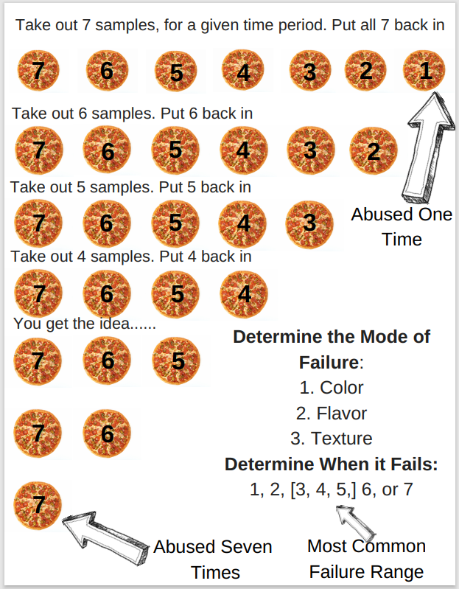

Determining an Accelerated Shelf Life Test or Abuse Test for Your Product
- Think about your product characteristics.
- Which characteristics are the most important?
- Which characteristics are the most likely to deteriorate first?

From your answers above:
- Does abuse testing or accelerated shelf-life make more sense?
- Look at the 7-cycle example to set up your abuse testing –OR-
- Research accelerated shelf-life studies of similar products to determine your parameters (typically time and temperature, sometimes relative humidity).
State how you chose your testing, what the predicted mode of failure is, and if the product fails after only one or two abuse cycles, what steps you would take to improve the resiliency/shelf life of the product. If abuse testing is used, it will be helpful to look up the shelf life of other similar products to set the shelf life specification.

Shelf Life References with Examples
Cereal Foods World – Not Your Mentor’s Shelf Life Methods (pdf)
Italian Journal of Food Safety – Experimental Accelerated Shelf Life Determination of Ready-To-Eat Processed Foods (pdf)

33

Finished Product Specifications

Purpose

Final product specifications are set to make sure a safe and quality product is consistently made. Specifications set the quality and safety parameters of the finished product along with information regarding packaging and storage. Specifications are used to determine product characteristics that would be out of spec or unacceptable to sell and how that product will be handled.
For attributes that you were unable to measure in the lab, research values for similar products to yours. This will likely be the case for microbiological specifications.

Methodology

Components of the Final Product Specification

1. Physical Attributes
- pH, Aw, moisture, etc. – how each is measured and what is an acceptable range.
- Flavor, color, texture, etc. – how each is measured and what is an acceptable range. Flavor profiles can be described as a specification.
- Size (diameter or dimensions), weight, height if applicable.

2. Microbiology
- TPC, pathogens, yeasts, and molds, etc – organisms to be tested for and an acceptable range, if any.
- See the Setting Ingredient Specification Chapter for specification examples and references.

3. Shelf-Life with Mode of Failure
See the chapter on Shelf Life and Abuse Testing for more information.

4. Packaging
- A diagram of the packaging showing the dimensions and materials used (be specific on types of plastics, layers in a laminated bag, etc.)
- Inner and outer package specs if applicable – search resources and suppliers for specifications as needed
- For films: thickness, heat sealability, vacuum packaging, any other functional attributes
- Individual weights or count if a multi-pack
- Case and pallet configuration – optional

5. Shipping and Handling Instructions
- Temperature control, weight limits on boxes, pallet size
- The course of action if the product is put on “hold”

34

Choosing Packaging for Your Product
Consider your food’s characteristics and what function(s) packaging needs to provide. Packaging functionality is diverse, but typically includes:
- Containment (holds the food)
- Protects the food (quality, safety, freshness)
- Maintains or extends product shelf life
- Communicates and markets information through the label
- Provides convenience or utility for the consumer

Food Packaging Range
- Includes everything from bulk packaging
  - Railcars and trucks
  - 2000 pound totes
  - 50-pound bags

- To retail packaging (like you see in the grocery store)
- To foodservice packaging
  - Take Out boxes
  - Bakery bags

Types of Packaging
- Primary – has direct contact with the food
  - Bottle, can, bag, etc.

- Secondary – contains multiple primary packages
  - Corrugated boxes, cases, stretch wrap

- Tertiary – bundling of secondary containers to allow easy transportation and distribution
  - Often stacked on a pallet and stretch wrapped

Packaging Materials
- Metal (and foil)
- Glass
- Paper and Paperboard
- Corrugated boxes (aka cardboard boxes)
- Plastics
- Wood crates

Packaging Materials Chosen Based on:
- Cost
- Packaging equipment in place
- Product compatibility
- Processing requirements
- Shelf life desired
- Packaging materials used need to be easy to fill (line speeds help determine cost)
  - All packaged food has identification included so it can be tracked (typically with a lot code and/or “best if used by” date)

Metal: Steel and Aluminum
- Used in cans and trays
- Able to form a hermetic seal, which is good for canning
- Steel
  - Has a non-corrosive coating of either tin, chromium, or aluminum on the inside
  - Manufactured into three-piece cans or two-piece cans

- Aluminum
  - Easily formed into cans with hermetic seals
  - Lighter weight than steel
  - Resists corrosion
  - Used in trays and aluminum foil
  - Aluminum foil provides an oxygen and light barrier

Glass
- Derived from silicon dioxide (sand)
- Used in forming bottles and jars
- Can form hermetic seals, which makes glass good for canning
- Disadvantage:
  - Glass needs to be thick enough to prevent breakage without being too heavy
  - Coatings can be applied to minimize damaging nicks and scratches

- Advantage:
  - 100% Recyclable

Paper
- Derived from the pulp of wood
- Includes additives for strength and barrier protection
- Generally recycled as long as the paper is not contaminated
- Pizza boxes have a wax coating
  - Makes the paper hard to recycle
  - Grease from the pizza is also a problem

- Thickness and layers of paper vary
  - Paper – thin and one layer
  - Paperboard – thicker, but still one layer
  - Corrugated paperboard – multiple layers of paperboard, often referred to as cardboard

Plastics
- Six basic types of plastics
- Chosen by characteristics that are needed:
  - Flexible and stretchable
  - Lightweight
  - Low-temperature formability (especially compared to glass)
  - Resistant to breakage
  - Strong heat sealability
  - Barrier properties for moisture and oxygen

- Not all plastics are good oxygen or gas barriers – small bottles will lose their carbonation faster than big bottles
- Plastics are generally not good light barriers.
- Derived from natural gas and petroleum.
- Hydrocarbon monomers are formed into plastic polymers.
- Recycled plastic is not used for food packaging.

Laminates and Material Combinations
- Multilayers of aluminum foil, paper, and/or plastic films
- Chosen to get optimal functionality from the packaging

Controlling Atmosphere Packaging
- Generally has reduced oxygen levels
- Modified Atmosphere Packaging is the most common.
  - Air is replaced with nitrogen or carbon dioxide.
  - Increase in shelf life possible
  - Reduces respiration of vegetables & other fresh foods.
  - Also used for meats, baked goods, coffees & teas, dairy products, and lunch kits
  - Can reduce the need for added preservatives

- Vacuum Packaging
  - All oxygen and most of the air is removed
  - Flexible packaging with a strong oxygen barrier is used
  - Helps prevent rancidity
  - There are restrictions on what can be vacuum packaged
  - Clostridium botulinum is a concern in anaerobic (no oxygen present) conditions

Active Packaging
- Packaging can “react” to changes in the internal environment
- Antimicrobial films
- Oxygen, carbon dioxide, and odor scavengers
- Steam release films
- Time-temperature indicators
- Microwave susceptor films allow browning

Aseptic Packaging
- The food and packaging are sterilized separately
- Food is then packaged in a commercially sterile environment to produce a safe product
- Typically shelf-stable

Safety Measures
- Tamper-Evident Banding/Seals
- Gives consumers security that the product has not been compromised.

Environmental Concerns
- There has been a push to reduce packaging over the last 10-15 years.
- Most packaging materials can be recycled, but not all are.
- Plastic recycling is complicated – lots of plastic is not recycled and recycled plastic is typically not food-grade.
Packaging Material content adapted from Essentials of Food Science (Vaclavik et al., 2014)

Choosing Your Packaging Material(s)
Focus on product packaging needs and the material characteristics to choose the packaging for your new product. Include multiple components and layers as needed.
- Light
- Oxygen
- Breakage (fragile products)
Does the packaging for your product need to provide an additional function? Examples include:
- Microwave susceptors
- Vacuum packaging
- Antioxidant addition
- Processing in package (canning, etc.)
- Convenience (heat in the container and/or eat out of the container, single-serve)
- What type of packaging is used for similar products?
- What type of packaging/filling equipment would your product require?
- What type of packaging can your product afford? (premium products are more likely to afford glass…)

Additional Considerations:

Where will your product be located?
- Refrigerated display case
  - Wide array of packaging options
  - Important – take fit, form, and function into account

- Freezer/Frozen Food Cases
  - Important – look at packaging performance

- Heated display case
  - Limited packaging options
  - Ventilation for this packaging is important
  - Think the rotisserie chicken packaging

Inventory Space reduction
- Increase the number of units per space in order to sell more
- Square and rectangular packaging is the most case ready
- Allows optimization of space within a case in order to get more product in the case
- Keeps case full and less handling by employees (where some damage come from – preventing food waste)

Decrease overall packaging costs
- Use a less expensive material that has the same function
- Higher price points for individual servings

35

Designing a Package Label
Designing a label is a blend of detail and creativity. Think about all of the components needed on the label before you start designing the label. Also, consider packaging layout and size. This will be important for determining what goes where and how much space you have for the design. Then get creative on how you want to make your package stand out on the grocery store shelves.

Requirements for a Food Label
- Statement of Identity or standard product name (in addition to the brand name)
- Net Quantity of Contents statement
  - How much is in the package?

- Component/Ingredient Statement
  - Listed greatest to least by weight
  - Include all of the ingredients within ingredients – look at food packages for examples – enriched flour, chocolate and syrups are just some of the ingredients that are made up of additional ingredients

- Nutrition Facts Panel – make sure to check ingredients, processing adjustments, and serving size in Genesis. Get your Nutrition Facts Panel approved before exporting it for your label
- Allergen Statement – see FSIS Compliance Guidelines on Allergens (pdf) for more information.
- Signature line or name and place of business of the U.S. manufacturer, packer, or distributor

Additional Label Material
- Bar Code – can be generated on Genesis or “borrowed” from the internet…
- “Best by” Date – set your date based on shelf-life testing and research
- Lot Code – used for tracking purposes
- Preparation &/or Storage Instructions (keep refrigerated, heat thoroughly, etc.)
- Label Claims
  - Nutrient Content Claims
  - Health Claims
  - Other truthful statements (vegan, kosher, third party verification, etc.)

- Marketing extras
  - Slogan
  - Promotional materials

- Choking Hazard Statement may be needed for some foods
  - Not required by FDA, but encouraged
  - For more information, check out Small Parts for Toys and Children’s Products Business Guidance.

- Meat & Poultry products need an Inspection Label – Check out the FSIS Label Reference (pdf) for more information.

Layout & Font Size
- Study FDA’s A Food Labeling Guide (pdf) – it is incredibly helpful for all components of the label and especially helpful for the layout requirements.
- Necessary to determine which part of your package is the Principal Display Panel (PDP) & Information Panel
- Then determine the area of the PDP for minimum type size permitted (especially for the net quantity statement)

What name should be used as the Statement of Identity?
- The name established by law or regulation, or in the absence thereof, the common or usual name of the food, if the food has one, should be used as the statement of identity.
  - If there is none, then an appropriately descriptive name, that is not misleading, should be used.
  - Brand names are not considered to be statements of identity and should not be unduly prominent compared to the statement of identity.
  - Check out 21 CFR 101.3(b) & (d) for more information.

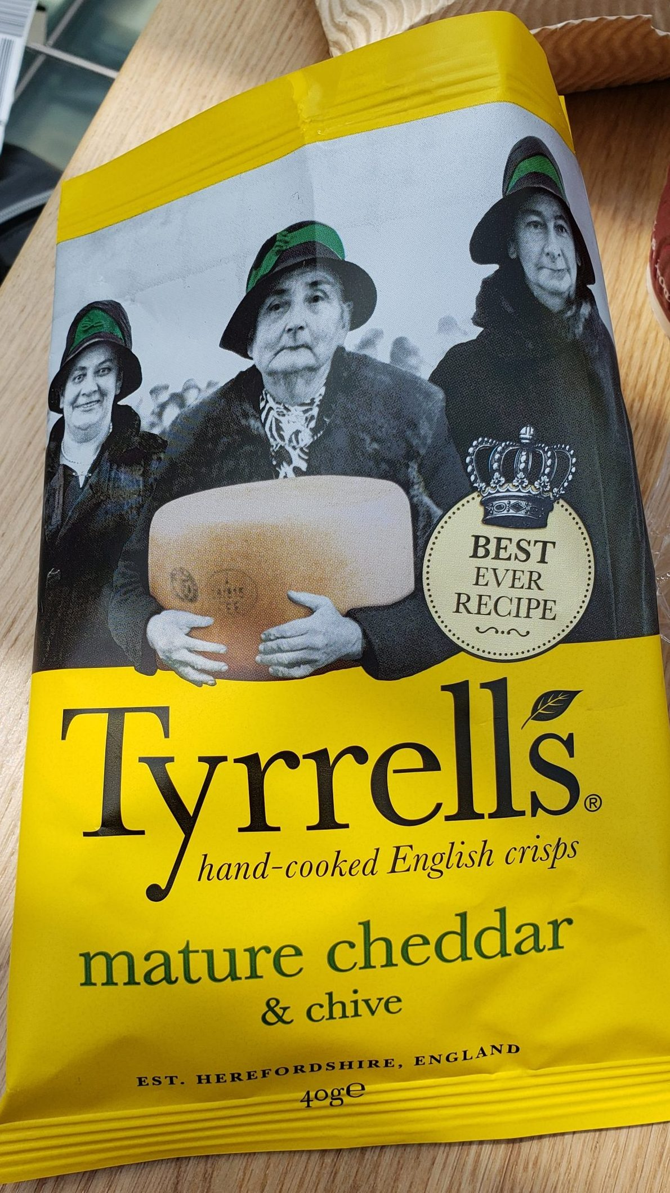

Be Creative – make your packaging stand out!
Here is a label (from England) that stands out on a crowded snack shelf.

End Goal
- Your team needs one finished label and package to submit.
- The approval process generally takes a few times to get it right.

How to Get Started
- Organize/create all of the material that is required for the label.
- Organize/create additional material (graphics, claims, etc.) that you would like to put on the label.
- Determine package material(s) & size/dimensions.
- Identify the principal display panel and then organize the layout accordingly.
- Canva is recommended for designing the label.
- Check out Packola.com for boxes (help with the layout).

Package Example – Bag Design

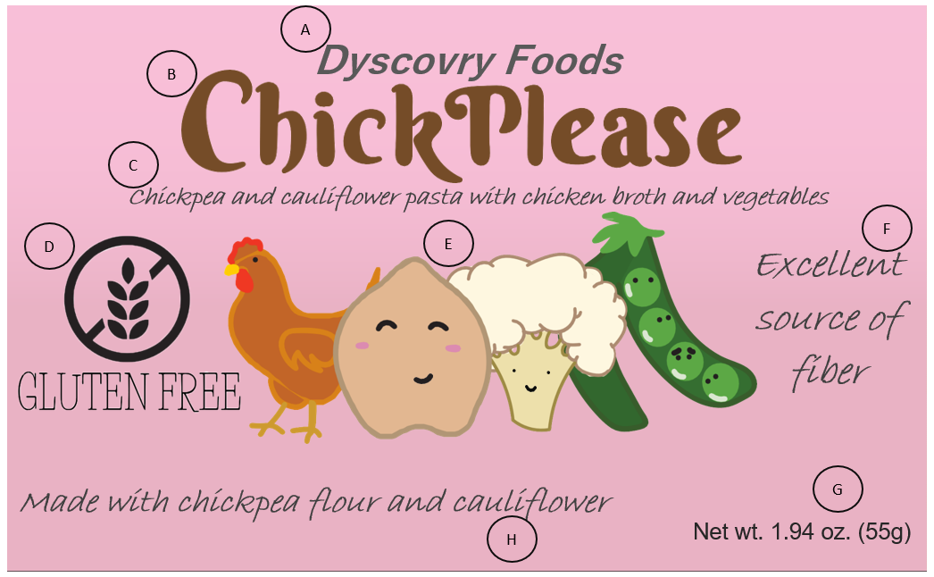

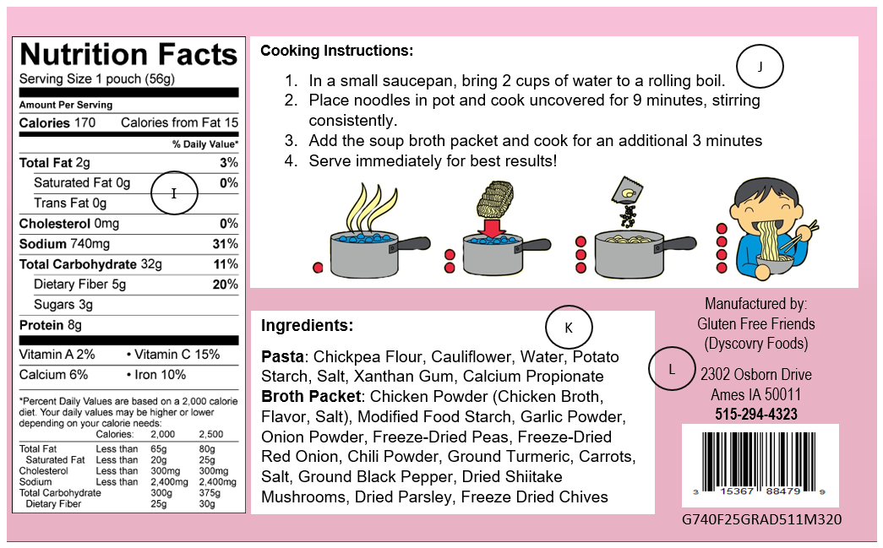

Legend:
- Company name
- Brand name
- Statement of Identity/standard product name
- Truthful statement
- Image for branding and consumer attraction purposes
- Nutrient Content Claim
- Net Weight Statement
- Ingredient callout for marketing & consumer attraction purposes
- Nutrition Facts Panel
- Preparation steps for product
- Ingredient Statement
- Manufacturer Address and Phone Number, Bar Code, and Lot Code/Tracking Code

36

Calculating Suggested Retail Price (SRP)

Calculating the Suggested Retail Price (SRP) for your product will be done using a model.
- While the model generally does a reasonable job estimating the SRP, note that some calculations may need to be adjusted for your product SRP to be realistic.
  - Adjustments are common for products with inexpensive ingredients and expensive packaging or possibly for products with intricate processing steps.

- Calculating ingredient costs for your product should be done based on your package size.
- Make sure to do one calculation at a time and check your work.

Ingredient Pricing
- The first step to determining your product’s suggested retail price
- Submit your ingredient list to faculty for pricing
  - A Google Sheet is provided for your team to submit your ingredient list.
  - Make sure to include all of the details (product name, code number, descriptors for grocery ingredients)
  - Faculty will contact suppliers for ingredient pricing (and will fill in the price per unit in the Google Sheet)
  - Watch the units and details with pricing.

- Method for Supplier Pricing
  - Request ingredient pricing for small to medium-size production amounts – this equates to pallet size for gums, truckload quantities for flour, sugar, etc.
  - Pricing is typically given as f.o.b., so some transportation cost is added to the base price. Transportation costs can vary widely, so an estimate is used.

- Method for Grocery Store Prices (Secondary Option)
  - Generally, take 60-70% of the grocery store price to get an ingredient cost
  - Sometimes ~90% of bulk online/restaurant pricing is used

Estimated SRP Calculations
- Start with your formula in percent by weight.
- Calculate the weight of each ingredient in pounds (or gallons for a few fluid ingredients) per package amount.
- Calculate the price of each ingredient in one package. Water (as long as it is not specially filtered) is considered part of the overhead cost and does not need to be part of the calculation.
- Add ingredient costs to get the total cost of all of the ingredients in one package.
- Calculate manufacturing costs by starting with a 55% base of the ingredient cost for manufacturing costs. Additional costs that may need to be added include:
  - 5% for each unit operation that the plant considers beyond “typical processing”, i.e. special equipment, additional processing steps, etc.
    - NOTE: Please check with faculty for processes that require an additional 5%.

  - Add 2% for each of the following: if you have refrigerated ingredients, refrigerated products, frozen ingredients, and/or a frozen product.
  - Add 15% for packaging costs, add 20% for unique or complex packaging (generally considered anything more than a bottle, bag, or bag in box)

- Add together ingredient costs and manufacturing costs. Then calculate an additional 4% for marketing and advertising costs.
- Calculate company cost to stores by adding 40% for company profit of the ingredient + manufacturing + marketing & advertising costs.
- Calculate SPR per package by adding 35% for store markup.

Example Calculations (note that is it helpful to wait and round values at the end of the calculations)
Table 1. Calculating Ingredient Costs for 1 Box of Hot Cocoa Dry Mix
Cocoa Dry Mix | Batch Wt. | % by wt. | Weight/Box (8 – 26 gram servings) | Weight/Box in pounds. | $/pound | $/Box
Sugar | 288 | 41.9 | 87.0688 | 0.19178150 | 0.41 | 0.07863041
Cocoa | 80 | 11.6 | 24.1904 | 0.05328282 | 0.89 | 0.04742171
Non-fat Dry Milk | 225 | 32.7 | 68.0160 | 0.14981498 | 0.99 | 0.14831683
Vanilla Powder | 20 | 2.9 | 6.0528 | 0.01333216 | 20.00 | 0.26664317
Marshmallows | 75 | 10.9 | 22.6720 | 0.04993833 | 0.85 | 0.04244758
 | 688 | 100.0 | 208.0000 | 0.45814978 |  | 0.58345970
Table 2. Calculations 1 Step at a Time for Hot Cocoa Dry Mix
Ingredient Cost per Box |  |  | $0.583
Manufacturing Cost | $0.583 x 70% = $0.408 | + $0.583 = | $0.991
Marketing & Advertising | $0.991 x 4% = $0.0396 | + $0.991 = | $1.031
Company Profit | $1.031 x 40% = $0.412 | + $1.031 = | $1.443
Store Markup | $1.443 x 35% = $0.505 | + $1.443 = | $1.948
The model shows a suggested retail price of $1.95 per box of 8 servings of hot cocoa mix. That seems about right based on current grocery store prices. The SRP will likely fluctuate based on ingredient and transportation costs.

After Calculating Your Suggested Retail Price (SRP)
- Check your work and ask yourself, does your cost make sense?
- Compare your SRP to competing products
- Let faculty know your SRP
- If your SRP is lower than expected, what is the reason why?
  - May need to adjust costing to account for model weaknesses

- If your SRP is higher than expected, what are the contributing factors, and could you adjust your ingredients/process/company profit to reduce your SRP?

1

Student Conclusions
You have now developed a product from start to finish. This is an accomplishment to celebrate. It is also a point to stop and reflect on what you have learned. Think back to where you started at the beginning of the semester. Likely ideation and deciding on your product concept feels like a long time ago. Formulation was exciting and likely nerve-racking as your team figured out how to make your product and found out if consumers were interested in buying. Processing brought new challenges and lots of documentation as your team planned for scale-up and researched how to produce a safe and consistent product. Commercialization just finished but may have felt like a whirlwind finalizing product details. As you reflect, answer the following questions.
- What experiences and learnings stand out?
- What surprised you about the process?
- What skills did you use and which skills did you work on and improve during the semester?
- What would you do differently the next time you develop a new product?
Your responses may range from the funny to the more observant. Examples include “food scientists need to know how to do everything” and “just because it should work, does not mean it will” to “what I have learned in this experience will help me get my first job”.

Next Steps
Your experience developing a product can be applied moving forward. In the product development process, your job is not quite done after the product has launched. Typically there are maintenance and improvement tasks including completing real-time shelf-life studies, monitoring issues with production, quality, and distribution, and possibly making changes based on consumer feedback. As you complete this course, you can double-check your career plans. What parts of the development process interested you the most? Are there components you thought you would like, but really did not enjoy? Was your interest sparked somewhere that surprised you? Spending some time with these questions will give you confidence in your job search as you plan for the future.
There is always more to learn, but do not forget your creativity, resourcefulness, communication, teamwork, and attention to detail. Those skills will serve you well in any career path you choose.

2

Instructor Notes

A Final Note and Request for Feedback
Putting together this lab manual was a large undertaking, but we recognize that it is not perfect or likely complete. We intend to make improvements and additions over time. We have not included examples of student work in this first version but will plan on adding them as we get permission from students. The lab manual is currently low on images mainly because it is difficult to find food industry images that can be used in OER. In short, we look at the lab manual as a living document that we will continue to revise and improve over time. To help us, your feedback is greatly appreciated, especially if you are using or plan on using the lab manual in your product development course. Your feedback can be shared here.

Using This Lab Manual
We have tried to remove course-specific details from this lab manual while still including complete instructions. There will be a variety of instances you may want to modify content. One of the ways this can be done is Book Cloning in Pressbooks. Cloning will allow you to copy the lab manual content and edit it as needed to essentially customize the lab manual for your specific course.

About References and Images.
We have linked references into the lab manual as much as we can. Finding well-written, applicable references that are freely available can be challenging. If you have found additional references for your product development course, please share them in the feedback form above.
Unless otherwise stated, all photos and images within this text were created by Kate Gilbert and are available under the same Creative Commons license as this book. The front cover images were kindly contributed by past students of the course: Erin Kyles (chocolate ravioli photo) and Emily Nienhaus (coconut custard spread photo).

